# logo-sql08.gif

SQL Server 2008 Compliance Guide

SQL Server Technical Article

**Writer:** JC Cannon, Denny Lee

**Contributors:** Andy Roberts, Ayad Shammout

**Technical Reviewers:** Dan Jones, Craig Gick, Jack Richins, Raul Garcia, Devendra Tiwari, Steven Gott, Al Comeau, Lara Rubbelke

**Published:** November 2008

**Applies to:** SQL Server 2008

**Summary:** This paper provides an overview of how to approach compliance for the management of the SQL Server database. It describes the compliance-related features of SQL Server 2008 and how to apply them to IT controls. This paper includes tips and scripts to help jump-start compliance solution development.

**Note:** You can [download the sample files](http://download.microsoft.com/download/e/d/3/ed3cdde1-0ffc-4abc-8bc2-d62f206d1a3d/SQLComplianceLab.exe) for this document.

Copyright

The information contained in this document represents the current view of Microsoft Corporation on the issues discussed as of the date of publication. Because Microsoft must respond to changing market conditions, it should not be interpreted to be a commitment on the part of Microsoft, and Microsoft cannot guarantee the accuracy of any information presented after the date of publication.

This white paper is for informational purposes only. MICROSOFT MAKES NO WARRANTIES, EXPRESS, IMPLIED, OR STATUTORY, AS TO THE INFORMATION IN THIS DOCUMENT.

Complying with all applicable copyright laws is the responsibility of the user. Without limiting the rights under copyright, no part of this document may be reproduced, stored in, or introduced into a retrieval system, or transmitted in any form or by any means (electronic, mechanical, photocopying, recording, or otherwise), or for any purpose, without the express written permission of Microsoft Corporation.

Microsoft may have patents, patent applications, trademarks, copyrights, or other intellectual property rights covering subject matter in this document. Except as expressly provided in any written license agreement from Microsoft, the furnishing of this document does not give you any license to these patents, trademarks, copyrights, or other intellectual property.

Unless otherwise noted, the example companies, organizations, products, domain names, e-mail addresses, logos, people, places, and events depicted herein are fictitious, and no association with any real company, organization, product, domain name, e-mail address, logo, person, place, or event is intended or should be inferred.

© 2008 Microsoft Corporation. All rights reserved.

Microsoft, Active Directory, ActiveX, BitLocker, Excel, Internet Explorer, PivotTable, PowerShell, SQL Server, Vista, Visual Basic, Visual Studio, Windows, Windows Server, and Windows Vista are trademarks of the Microsoft group of companies.

All other trademarks are property of their respective owners.

Contents

Introduction 7

How to Use This Document 7

Document Focus 7

Document Prerequisites 7

Understanding Compliance 7

Deconstructing GRC 8

Risk Management 8

Governance 9

Compliance 9

A GRC Example 10

Mitigating Controls 11

Key Performance Indicators and Key Risk Indicators 11

Mapping Regulations to a Core Set of IT Controls 11

Implementing IT Controls with SQL Server 2008 13

Securing the Platform 13

Securing SQL Server 2008 14

Managing SQL Server 2008 Surface Area Configuration 14

Controlling Identity and Separation of Duties 15

Using Windows Authentication 16

Creating Logins 17

Assigning Users to Server Roles 18

Granting Database Access 19

Assigning Users to Database Roles 20

Managing Permissions 21

Server Role Permissions 21

Database Permissions 22

Column-Level Permissions 23

Separation of Duties 25

Limiting Use of sysadmin 25

Disabling the sa Account 25

Using Signed Procedures to Act as sysadmin (Disabling All sysadmin Accounts) 25

sysadmin Accounts Defined During Setup 26

Assignment of sysadmin During SQL Server 2008 Setup 26

Assignment of Service SIDs in Windows Vista and Windows Server 2008 28

Use of BUILTIN\Administrators Group 28

Identity Management with Multitiered Applications 28

Encrypting Database Data 29

SQL Server Database Encryption 29

Selecting an Encryption Algorithm 29

Using Transparent Data Encryption 29

Backing Up the Certificate Private Key 30

Rotating Certificates vs. Rotating Keys 30

Monitoring Key Access 31

Monitoring Database Encryption Flag 32

Addressing Specific Scenarios 32

Protecting Against a Stolen Computer 32

Preventing sysadmin and dbo Access 32

Protecting a Column in a Database Table 32

Auditing Sensitive Operations 33

Collecting Logs 34

Transferring Logs 34

Using Scripts and Tools to Manage Auditing 34

Auditing Specific Users and Tables 35

Auditing Specific Users 35

Auditing Specific Tables 36

Tracking sysadmin and db_owner Access 36

Centralizing Logs 36

Creating Reports from Log Files 37

Overview – Server Actions 37

Server Action Trend Analysis 38

Drilling Through to the Server Action Details 38

Overview – Database Actions 39

Drilling Through to the Database Actions 39

Overview – DDL Actions 40

Drilling Through to the DDL Actions 40

Overview – DML Actions 42

Drilling Through to the DML Actions 42

Using Policy-Based Management to Define, Deploy, and Validate Policy 43

Policy-Based Management Structure 43

Policy-Based Management Example 44

Monitoring Policy-Based Management Policies 44

Using Policy-Based Management to Address Compliance 44

Create a Plan 44

Based on the Plan, Which Set of Policies Do You Want to Create? 46

Determining Execution Mode for Your Policies 46

Using Policy-Based Management to Implement KPIs and KRIs 48

Using Policy-Based Management to Validate Auditing Configuration 49

Using Policy-Based Management to Validate Encryption Configuration 49

Deploying Policies 50

Creating Policy-Based Management Reports 51

Helpful Scripts and Tips 55

Programming Interfaces to SQL Server 55

SMO 55

Transact-SQL 55

Windows PowerShell 55

VBScript 56

Windows Data Access Components 56

Ensuring Security Settings (Server Security Policy.xml) 57

Managing Separation of Duties (SOD Policy.xml) 59

Using Scripts in Conditions 60

Disabling All sysadmin Accounts (ManageSA.sql) 61

Validating the sa Account (ValidateSA.sql) 62

Validating sysadmin Role Membership (ValidateSysadmins.sql) 62

Enforcing Separation of Roles (SOD Policy.xml) 63

Monitoring Server Roles (ValidateServerRoles.sql) 63

Listing Users in Multiple Roles (ValidateServerRoles.sql) 64

Monitoring Database Roles (ValidateDatabaseRoles.sql) 66

Managing Encryption Keys 67

Monitoring Access to Encryption Keys (AuditCryptoActions.sql) 67

Viewing Certificates and Keys (ViewKeys.sql) 67

Rotating Certificates (RotateCerts.sql) 69

Backing Up the Certificate Private Key (BackupCerts.sql) 70

Ensuring Certificate Rotation and Backup (CertRotationPolicy.xml) 71

Managing Auditing 71

Transferring SQL Server Audit Logs to a Table (StoreAuditLogs.sql) 71

Using SSIS to Move Logs to a Database Table (LoadLogsPackage.dtsx) 75

Accessing SQL Server Audit Events by Using Excel (AuditReport.xlsx) 78

Getting an IP Address from an Audit Log 80

Audit Project 81

Managing Policy-Based Management Policies 85

Creating a Policy by Using PowerShell 86

Deploying Policy-Based Management Policies by Using PowerShell (DeployPBMPolicies.ps1) 86

Transferring Policy Health Checks into a Database Table 87

Conclusion 91

# Introduction

Organizations across the globe are being inundated with regulatory requirements. They also have a strong need to better manage their IT systems to ensure they are operating efficiently and staying secure. Microsoft is often asked to provide guidance and technology to assist organizations struggling with compliance. The SQL Server 2008 Compliance Guidance white paper was written to help organizations and individuals understand how to use the features of the Microsoft® SQL Server® 2008 database software to address their compliance needs. This paper serves as an accompaniment to the SQL Server 2008 compliance software development kit (SDK), which provides sample code and guidance for understanding SQL Server 2008 compliance features and using them for developing solutions.

# How to Use This Document

This document provides compliance guidance at various levels. The first part of this paper describes general compliance concepts, where IT controls can be used to minimize risks and how to use technology for the implementation of those controls. The second part addresses specific compliance scenarios such as securing the platform and protecting data. The third part of this paper contains sample code, examples, and tips that can be used to accelerate the creation of custom compliance-related solutions being built on top of SQL Server 2008. The SDK can also be used on its own for implementation of IT controls. The readme file that comes with the SDK can assist with this.

## Document Focus

This document is meant to provide general guidance on using SQL Server 2008 to address compliance needs. It also points to high-level compliance guidance provided by Microsoft’s Solution Accelerator Team as well as guidance for addressing security in the Windows Server® operating system.

## Document Prerequisites

Readers of this document should have a general understanding of SQL Server in order to better appreciate the concepts presented here. The Compliance Hands-on-Lab in the SDK will assist with the understanding of the compliance-related features of SQL Server 2008.

# Understanding Compliance

Compliance affects many organizations, large and small. Regulatory requirements such as Sarbanes-Oxley and PCI-DSS are a major driver for compliance. However, even companies that are not impacted by regulatory requirements need to reach compliance with their own organizational policies. The problem often appears when companies begin to initiate a compliance program. They may not be sure where to begin or how to automate the program using technology, specifically SQL Server.

Compliance is the final step in a three-step process called GRC or governance, risk management, and compliance. Organizations looking to develop a GRC program should consider seeking assistance from a compliance consultant. Forrester, an analyst firm that tracks the GRC industry, has created a [report](http://www.forrester.com/Research/Document/0,,40476,00.html) on GRC consulting firms that provides a list of companies that can be considered for assistance. The next section takes a look at the term *GRC* and how SQL Server can be integrated into a GRC program.

## Deconstructing GRC

GRC helps companies to identify risks, mitigate those risks, and verify that the risks have been mitigated over time. Figure 1 provides an overview of each of these concepts.

**Figure 1:** GRC deconstructed



### Risk Management

Risk management is a program for mitigating or removing risk. It starts with an assessment of each area of an organization to determine where risks may exist. Each department, such as security, operations, sales, and development, can perform its own risk assessments. To begin with, companies should work with a compliance auditor to perform a risk assessment of their organization. After risks are identified, they should be prioritized, and based on those priorities, an action plan should be put into place. The plan should determine how each risk will be addressed: Should the risk be ignored, mitigated, or avoided?

**Ways to address the risk of storing credit card data**

* Ignore – don’t improve protection of credit card data.
* Mitigate – improve protection of credit card data.
* Avoid – don’t collect credit card data.

Risks that are targeted to be mitigated should be prioritized, and a plan should be put into place to mitigate each risk. As each department identifies and prioritizes its risks, it must be sure to align them with organizational risks. Departmental priorities must not override organizational ones.

### Governance

Governance represents the actions taken to address the risks identified during the assessment. This is the step where policies, IT controls, practices, systems, and training are put into place to mitigate risks. Mitigating controls, discussed below, can be used in circumstances where policies cannot be strictly enforced or risks cannot be avoided. For example, SQL Server cannot prevent the sysadmin from viewing sensitive data. However, the **sysadmin** account can be disabled and all accesses by the sysadmin can be monitored to ensure that sensitive data is not being inappropriately accessed.

**Ways to apply governance to protecting sensitive data**

* Create policies that describe proper handling of sensitive data.
* Train employees on data handling policies.
* Apply policies to systems that store sensitive data.
* Monitor and log handling of sensitive data to ensure policies are followed.

### Compliance

Compliance is the validation that identified risks are being mitigated. Here are examples of how risks can be validated. Firstly, for each identified risk, is there a policy in place for avoiding or mitigating the risk? Secondly, have the appropriate people been informed of the policies? Thirdly, have the policies been deployed via processes, software, or IT controls? Fourthly, are policies being monitored to ensure compliance, and when breaches in policy occur are they quickly remediated? For true compliance, each step must be verifiable by an auditor. This is where audit reports, event logs, video tapes, and version history can help.

**Ways to validate compliance**

* Show that policies have been developed to address identified risks.
* Show that policies have been deployed where appropriate.
* Prove that policies have been in place and followed during the enforcement period.

Compliance with organizational policies and regulatory requirements is usually performed by internal auditing team and professional auditing firms. Be sure you have systems in place that make it easy for auditors to validate compliance. Centralization of auditing systems helps to improve the efficiency of compliance auditing. These techniques will lower auditing costs and minimize disruption to daily operations.

## A GRC Example

Using the GRC guidelines from the previous section, let’s look at how you could apply those guidelines to assessing the need for protecting building access as shown in **Figure 2**.

**Figure 2:** GRC example



**Risk Management**

Performing a risk assessment of the building, you might determine that a security policy is necessary to reduce the risk of loss of computer and office equipment, personal items, and intellectual property due to theft. There could also be a risk to employees from attack or robbery. The building itself could be vandalized. Each of these risks could negatively impact an organization’s bottom line if it were to materialize.

**Governance**

After the assessment has been completed, a set of policies and processes are defined and prioritized for implementation. Policies are created on proper building access and the protection of entryways. Training is provided to employees on these policies. Electronic locks are placed on doors that can only be opened with employee badges. Badges are assigned to employees, limiting their access to buildings based on need. Cameras and guards are placed at vulnerable locations to help enforce policies.

**Compliance**

To validate compliance with corporate access policies to an auditor, the entrance logs can be reviewed to show that the logs are properly collecting data and the employees listed in the logs had a legitimate need to access the building. The tapes from the camera can be reviewed to ensure that employees were following access policies and nonemployees were not getting into the building. Additionally, an auditor could interview guards and read past news reports to validate that incidents involving the building had not occurred.

## Mitigating Controls

[Mitigating controls](http://en.wikipedia.org/wiki/Mitigating_Controls), also known as compensating controls, help to reduce the risks from a control that cannot be totally enforced. In the GRC example above, the camera acts as a mitigating control to see whether individuals are entering the building without using their badges to gain entry. While the electronic lock on the door forces an individual to use his or her badge to open the door, it does nothing to stop that same person from walking into the door after someone else has opened it.

Auditing is often used as a mitigating control in computer systems to monitor sensitive operations that cannot be blocked. For example, system administrators often have access to all system data although they are not always authorized to view the data. Monitoring the system administrators’ actions can help to determine whether access policies are being followed.

SQL Server 2008 introduces two features that can be used in developing mitigating controls. [SQL Server Audit](http://technet.microsoft.com/en-us/library/cc280526(SQL.100).aspx) can monitor sensitive operations and privileged accounts such as the **sa**. [Policy-Based Management](http://technet.microsoft.com/en-us/library/bb510667(SQL.100).aspx) helps to ensure that critical configuration settings are set to the appropriate value and remain that way. In each case, while it may not be possible to block certain operations, accounts, or configuration settings, the risk that they pose can be mitigated by the use of these two new features.

## Key Performance Indicators and Key Risk Indicators

[Key performance indicators](http://en.wikipedia.org/wiki/Key_performance_indicator) (KPIs) are settings or measurements that show that your company, department, or systems are performing as expected. The values or ranges for KPIs are normally set by business decision makers. Some IT controls can be used as KPIs. For example, database query performance, CPU utilization, available memory, and available connections can all be measured as indicators of a healthy system.

[Key risk indicators](http://en.wikipedia.org/wiki/Key_risk_indicator) (KRIs) are settings or measurements that may show that your business, department, or systems may be at risk. The values or ranges for KRIs are normally set by technical decision makers. IT controls are often used to implement KRIs. Examples of KRIs include currency of security patches, enablement of encryption, number of individuals assigned to the administrators role, and frequency of backups.

For information about how to use Policy-Based Management to implement KPIs and KRIs, see Using Policy-Based Management for implementing KPIs and KRIs later in this document.

## Mapping Regulations to a Core Set of IT Controls

The definition of policies to comply with regulations often leads to the development of [IT controls](http://en.wikipedia.org/wiki/IT_Controls) for implementing the policies. For example, a policy that calls for access to credit card numbers to be restricted may require IT controls for strong authentication, password guidelines, and the application of encryption. While some controls are implemented using business processes, many controls can be applied using technology.

**Figure 3** below provides an example of the IT controls that may be required by some of the more common US regulations. Microsoft’s [IT Compliance Planning Guide](http://www.microsoft.com/technet/security/guidance/complianceandpolicies/compliance/rcguide/default.mspx) provides guidance on how to map regulations to a core set of IT controls and to the Microsoft technology that can assist with the creation of those controls.

**Figure 3:** SOX: Sarbanes Oxley Act. PCI: Payment Card Industry HIPAA: Health Information Portability and Accountability Act GLBA: Graham Leach Bliley Act



The next sections of this paper are broken down by the noted IT controls.

|  |  |
| --- | --- |
| **Icon** | **Description** |
|  | Identity management |
|  | Separation of duties |
|  | Encryption |
|  | Key management |
|  | Auditing |
|  | Policy-Based Management |

# Implementing IT Controls with SQL Server 2008

SQL Server 2008 has several features that provide the ability to implement database-related IT controls. In addition, some IT controls can be implemented using the platform on which SQL Server is installed. It is important that the compliance team within your organization define the IT controls that need to be implemented and determine which ones will apply to the database. The following sections look at the features that can be used to implement IT controls. The areas to be covered include:

* Securing the Platform

This section describes actions to be taken before installing software or configuring the database. These actions will help to mitigate risks to the operating system and database application.

* Controlling Identity and Separation of Duties

This section provides recommendations for defining database principals and helping to enforce separation of duties.

* Encrypting Database Data

This section looks at the encryption features of SQL Server 2008. It includes a discussion of often overlooked concerns around encryption.

* Auditing Sensitive Information

This section looks at the new auditing feature of SQL Server 2008 and how to use it for centralized log collection and reporting.

* Using Policy-Based Management to Define, Deploy, and Validate Policy

This sections looks at the Policy-Based Management feature of SQL Server 2008 and how to use it for managing multiple databases using a single policy.

# Securing the Platform

Before attempting to apply policies to or implement IT controls with SQL Server, ensure that you have prepared a secure base for installing SQL Server:

* Use the latest operating system with current service packs.
* Install the most current security patches.
* Install antimalware software.
* Minimize the operating system surface area for attack:
  + Limit running services.
  + Install only software needed to support server role.
  + Disable unnecessary ports.
  + Configure the firewall.
* Limit the users that have access to the server and their roles.

For more information, including prescriptive guidance on securing Windows Server 2008, download the [Windows Server 2008 Security Guide](http://technet.microsoft.com/en-us/library/cc264463.aspx).

### Securing SQL Server 2008

After the platform has been secured, SQL Server should be installed and secured before policies are applied and IT controls are developed. For more information, including guidelines for securing SQL Server 2008, see the white paper [Securing SQL Server](http://msdn.microsoft.com/en-us/library/bb283235.aspx).

### Managing SQL Server 2008 Surface Area Configuration

Beginning in SQL Server 2008, the Surface Area Configuration tool has been removed. The features of the Surface Area Configuration tool that control SQL Server behavior have been replaced and greatly enhanced by the Policy-Based Management feature. **Figure 4** shows PBM’s surface area configuration facet screen. There are also surface area configuration facets for Analysis Services and Reporting Services. For more information about managing surface area configuration, see [Understanding Surface Area Configuration](http://msdn.microsoft.com/en-us/library/ms161956.aspx).

**Figure 4:** Policy-Based Management Surface Area Configuration facet

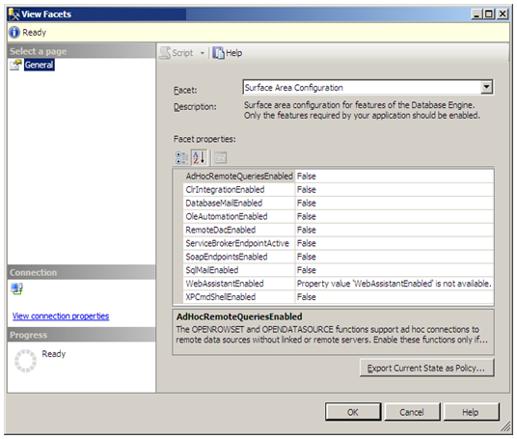

The connectivity management features of the Surface Area Configuration tool shown in Figure 4 are available by using [SQL Server Configuration Manager](http://msdn.microsoft.com/en-us/library/ms174212.aspx). **Figure 5** displays the SQL Server Configuration Manager nodes for configuring services, the network, and protocols.

**Figure 5:** SQL Server Configuration Manager

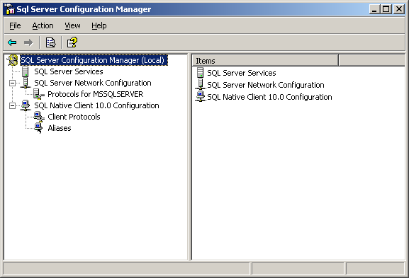

SQL Server configuration can be managed using the [sp_configure](http://msdn.microsoft.com/en-us/library/ms189631.aspx) stored procedure. It permits you to manage settings such as:

* Backup compression.
* Common criteria enablement.
* Common language runtime enablement.
* Remote access.
* User connections.

# Controlling Identity and Separation of Duties

The first step to restricting access to database data is to limit who can access the database. SQL Server 2008 provides various means for managing who can access a database and which operations can be executed by database users. **Figure 6** indicates the various levels of identity management provided by SQL Server 2008. In addition, special [permissions](http://msdn.microsoft.com/en-us/library/ms191291.aspx) can be granted or denied to users. Before providing access to users; plan who should have database access, at which level, and to which operations. Then follow these guidelines:

* Use Windows Authentication for all database logins.
* Grant users access to databases as needed.
* Grant and deny needed permissions for users.
* Place users in roles necessary to perform their jobs.
* Use Policy-Based Management to validate identity policies.

**Figure 6:** Evolution of database user definition



## Using Windows Authentication

Identity management is the most important step to protecting the database, after validation of a secure platform. The first part of identity management is providing the ability to identify each person that is accessing the database.

Using Windows Authentication mode ties the SQL Server identity to an Active Directory® account, providing a strong identity. Integrating access management with Active Directory Domain Services (AD DS) provides several benefits for SQL Server:

* Consistent identity across all servers
* Centralized password policy enforcement
* Centralized means for disabling accounts

For information about account provisioning, see [Database Engine Configuration - Account Provisioning](http://msdn.microsoft.com/en-us/library/cc281849(SQL.100).aspx).

Windows Authentication mode is enabled using the **Security** page of the **Server Properties** dialog box in SQL Server Management Studio, as shown in **Figure 7**.

**Figure 7:** Server security properties

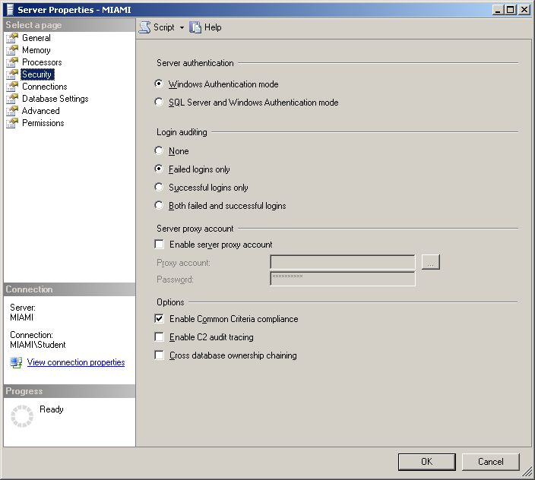

Policy-Based Management can be used to create a policy to ensure that security settings are in place and haven’t changed. Use the Policy-Based Management Server Security facet to create a policy for this setting. For more information about using Policy-Based Management for validating settings, see Using Policy-Based Management to Define, Deploy, and Validate Policy.

## Creating Logins

To access a database, a user must first be assigned a login. A login can be assigned to a user by using the user’s Windows® account or a Windows security group to which a user belongs. For information about creating logins, see [How to: Create a SQL Server Login](http://msdn.microsoft.com/en-us/library/aa337562.aspx). Using individual user accounts instead of security groups provides more control over the logins, because Windows administrators could add new users to the security group without the knowledge of database administrators. However, security groups require less administration. Below is an example of a script to create a login from a Windows account.

CREATE LOGIN [SQLVM03-18158EA\Pat] FROM WINDOWS

The **Login - New** dialog box shown in **Figure 8** can be used to create a new login for a database. It can be accessed by right-clicking on the Logins folder of the server instance and then clicking **New Login**.

**Figure 8:** **Login - New** dialog box

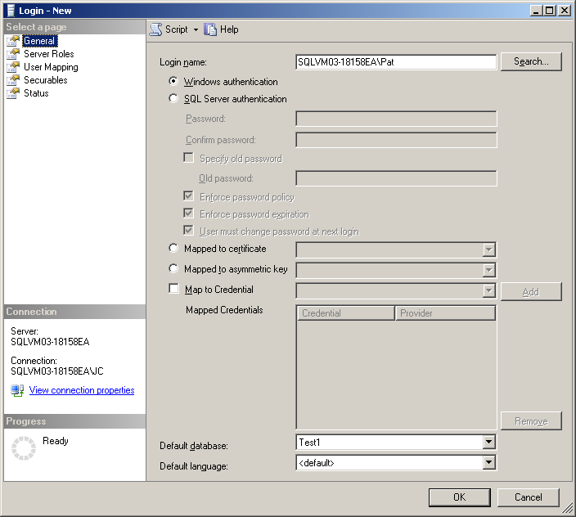

## Assigning Users to Server Roles

Logins that have been defined in SQL Server should be assigned to an appropriate server role within SQL Server. Assigning logins to a role other than **sysadmin** helps to limit their access to a specific set of server operations. For example, assigning a login to the **dbcreator** role permits it to create, alter, drop, and restore any database. However, it is restricted from performing other operations. A list of fixed database roles, along with the operations they can perform can be found at [Server-Level Roles](http://msdn.microsoft.com/en-us/library/ms188659.aspx). Below is a script that provides an example of how to assign a user to a server role.

sp_addsrvrolemember N'SQLVM03-18158EA\Pat', N'dbcreator'

The property page in **Figure 9** can be used to assign server roles to a login. It can be accessed by right-clicking a login, clicking **Properties**, and then clicking the **Server Roles** tab.

**Figure 9:** Server login server roles

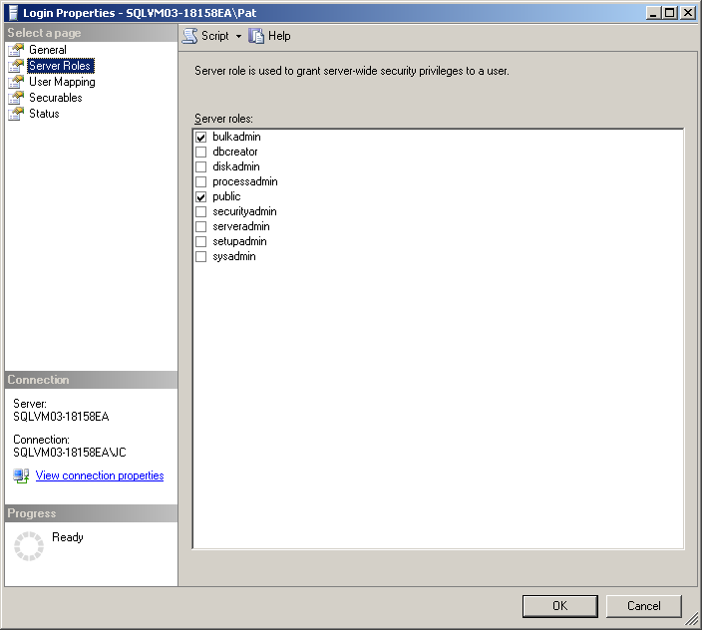

## Granting Database Access

After a login is created, it must still be granted access to a database before its data can be accessed. Care must be taken to only grant the appropriate people access to a database. And when that is done, care should be taken to restrict the type of access that is given. For more information about granting logins access to a database, see [How to: Create a Database User](http://msdn.microsoft.com/en-us/library/aa337545.aspx). Below is a script that provides an example of how to grant a login access to the Test1 database.

USE Test1

CREATE USER [Pat] FOR LOGIN [SQLVM03-18158EA\Pat]

The **Database User - New** dialog box in **Figure 10** can be used to assign a login to a database. The dialog can also be used to assign a user to a schema and database roles. It can be accessed by right-clicking on the **Users** folder of a database and then clicking **New User**.

**Figure 10:** **Database User -New** dialog box

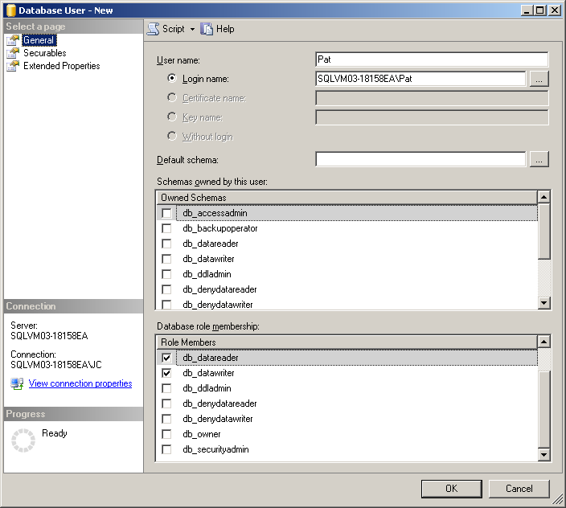

## Assigning Users to Database Roles

Users that have been granted access to a database in SQL Server should be assigned to an appropriate database role. Assigning users to a role other than **db_owner** helps to limit their access to a specific set of database operations. For example, assigning a user to the **db_datareader** role permits the user to read data from all database tables. However, the user is restricted from performing other operations. A list of fixed database roles, along with the operations they can perform, can be found at [Database-Level Roles](http://msdn.microsoft.com/en-us/library/ms189121.aspx). Below is a script that provides an example of how to assign a user to database roles to permit reading and writing database data.

sp_addrolemember N'db_datareader', N'Pat'

sp_addrolemember N'db_datawriter', N'Pat'

Database roles can also be assigned during user creation with the **Database User - New** dialog box as described in the section Granting Database Access.

## Managing Permissions

Permissions are privileges or operations that are granted or denied to database users and logins. When a login or user is assigned to a role, he or she inherits a set of permissions that are mapped to the role. Alternatively, permissions can be granted to users and logins on their own. For more information, including a list of permissions, see [Permissions (Database Engine)](http://msdn.microsoft.com/en-us/library/ms191291.aspx).

Permissions can be used to provide granular rights to users and limit the rights they might normally inherit due to their role membership. For example, a database user that is assigned to the database roles **db_datareader** and **db_datawriter** can be denied the ability to delete entries by using a DENY command. This technique could be used to permit a user to create and update sales entries but not delete the entries. The following script can be used to deny the ability for a user to delete rows from the table CCTable1.

DENY DELETE ON OBJECT::CCTable1 TO [Pat]

**Note:** Some system stored procedures and DBCC commands check for role membership but not permissions when they execute operations. Always validate that permissions perform the way that you expect them before you release them into production.

### Server Role Permissions

Each server role has a set of permissions that are mapped to it. These roles make it easier to assign a set of permissions to a user. For more information, including the set of permissions assigned to fixed server roles, see [Permissions of Fixed Server Roles (Database Engine)](http://msdn.microsoft.com/en-us/library/ms175892.aspx). Below is an example of a script for applying a server permission.

GRANT ALTER ANY LOGIN TO [SQLVM03-18158EA\Pat]

The **Login Properties** page, shown in **Figure 11**, can be used to grant or deny server permissions for a login. The **Explicit** tab lists the permissions individually along with the ability to grant, deny, or permit the login to grant a permission. The **Effective** tab lists the permissions that are granted to a login based on the login’s role membership. In the example in **Figure 11**, Pat is denied delete permission on table **CCTable1**.

**Figure 11:** Server login permissions

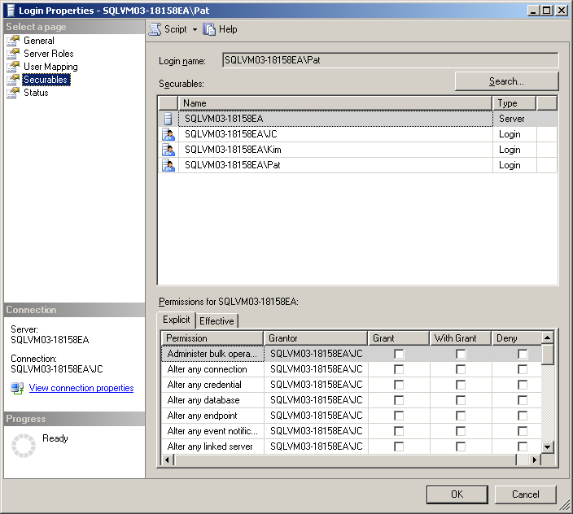

### Database Permissions

Each database role has a set of permissions that are assigned to it. The set of permissions assigned to fixed database roles can be found at [Permissions of Fixed Database Roles (Database Engine)](http://msdn.microsoft.com/en-us/library/ms189612.aspx). Below is an example of a script for applying a database permission.

USE Test1

GRANT CREATE TABLE TO [SQLVM03-18158EA\Pat]

The **Database User** page in **Figure 12** can be used to grant or deny database permissions for a user. The **Explicit** tab lists the permissions individually along with the ability to grant, deny, or permit the user to grant a permission. The **Effective** tab lists the permissions that are granted to a user based on the user’s role membership.

**Figure 12:** Database user permissions

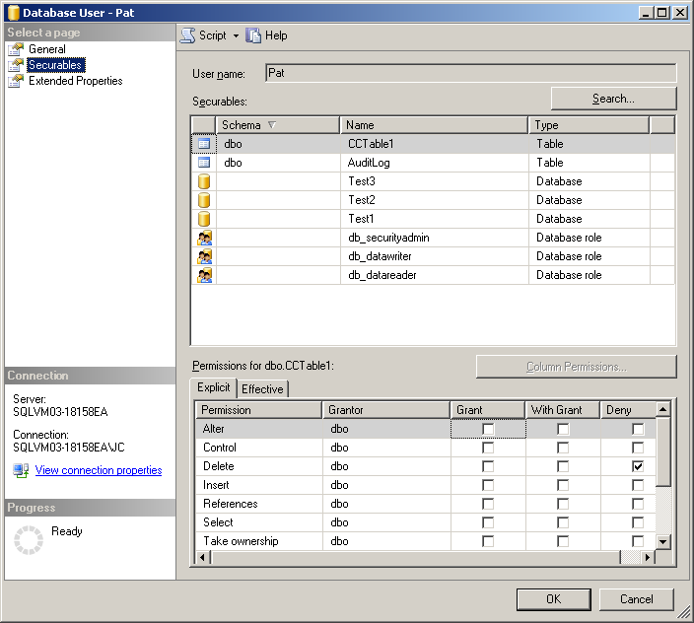

### Column-Level Permissions

Column-level security can be used to prevent a user from accessing specific columns in a table. Use the [DENY object permission](http://msdn.microsoft.com/en-us/library/ms173724.aspx) to prevent access to a column. Below is an example of a script for denying access to a column.

DENY SELECT ON [CCTable1] ([CCNumber]) TO [SQLVM03-18158EA\Pat]

**Note:** A query fails if it includes a column to which a user does not have access. For example, using SELECT * will not work against a table that has a column that has been denied access to the user. It is recommended that applications include the specific columns needed in a query and not use SELECT *.

The table properties page for a database table, shown below, can be used to block access to specific columns in a table. The example in **Figure 13** shows Pat being denied access to the credit card number column. The user must be granted SELECT permissions on the table before the **Column Permissions** button is enabled.

**Figure 13:** Granting and denying database column permissions

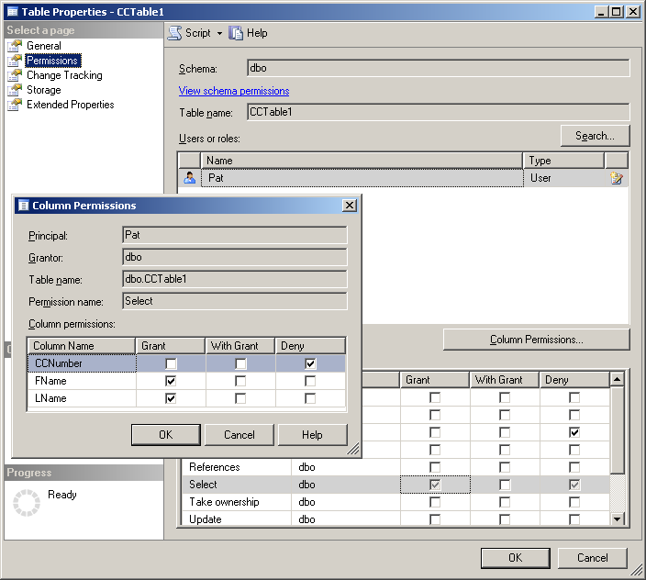

# Separation of Duties

[Separation of duties](http://en.wikipedia.org/wiki/Segregation_of_duties) (SOD), also known as segregation of duties or role separation, is an important consideration when managing identity and permissions. It helps to mitigate threats that can be executed by an individual and provide validation that tasks are being executed properly. For example, when there is a separate author, reviewer, and approver assigned to a task, each person can help to ensure that the others are staying within the bounds of their assigned duties and that mistakes are not being made during the execution of a task. SOD has two main objectives:

* Ensuring users are not in conflicting roles (e.g., reviewer and approver).
* Ensuring that users in a specific role can’t execute operations outside of their role.

Many data controllers want to be able to prevent highly-privileged users from accessing their sensitive data. Today SQL Server cannot prevent the members of the **sysadmin** role from performing specific operations that may be in conflict of SOD rules. However, mitigating controls can be created to help reduce the risk from a **sysadmin** performing inappropriate operations. Firstly, the **sa** account can be disabled. Secondly, the members of **sysadmin** can be reduced to those absolutely necessary. Thirdly, when a **sysadmin** performs an operation, each operation can be audited and reviewed. Furthermore, Policy-Based Management can be used to validate that each of these controls is in place. For examples of using Policy-Based Management to manage separation of duties, see Managing Separation of Duties.

## Limiting Use of sysadmin

Members of the **sysadmin** server role in SQL Server have the ability to perform any function in the database. Therefore, the decision to place individuals in this role should not be take lightly. The privileges should be given to a minimum set of users. It is a good idea to have more than one admin as a backup but not a good idea to distribute the privileges too broadly.

### Disabling the sa Account

Realistically, the **sa** account is not needed to manage SQL Server and should not be used. The **sa** account does not map to a specific individual, which makes it difficult to determine who is using the **sa** account. SQL Server Management Studio can be used to rename the account to ensure that applications are not using it. The account can also be disabled to ensure that users cannot log in using the account.

### Using Signed Procedures to Act as sysadmin (Disabling All sysadmin Accounts)

Disabling all **sysadmin** accounts can be problematic, because only a **sysadmin** can re-enable the **sa** account and/or run certain commands such as [DBCC PINTABLE](http://msdn.microsoft.com/en-us/library/aa258284(SQL.80).aspx). However, this limitation can be overcome through the use of [signed procedures](http://msdn.microsoft.com/en-us/library/ms181700.aspx). A signed procedure **can** be run under the **sysadmin** role by database users that are not members of the **sysadmin** role. Such a procedure can be used to enable and disable all **sysadmin** accounts. For more information, see Disabling All sysadmin Accounts. They can also be used to perform operations normally reserved for the **sysadmin**. This permits these actions to be performed by lower-privileged users without permitting them to have all the permissions of a **sysadmin**.

**Note:** Avoid granting the [CONTROL SERVER](http://msdn.microsoft.com/en-us/library/microsoft.sqlserver.management.smo.serverpermissionset.controlserver.aspx) permission to a login. This permission will permit the user to execute many of the operations of a **sysadmin**. In addition, the user will be able to impersonate the **sa** account event if the account is disabled. If you must grant the CONTROL SEVER permission to a user, do so in conjunction with the DENY IMPERSONATE for each **sysadmin** account. For example:

USE master

DENY IMPERSONATE ON LOGIN::Yukonsa TO [SQLVM03-18158EA\Pat];

## sysadmin Accounts Defined During Setup

The tables below describe the principals that are defined to the **sysadmin** role during fresh installs. For upgrades, the current membership of the **sysadmin** role will not be changed.

### Assignment of sysadmin During SQL Server 2008 Setup

Service accounts are assigned to the SQL Server services during installation. However, it is recommended that these accounts be switched to domain or local user accounts to prevent other applications that run under the same services from having access to SQL Server resources. For more information about assigning service accounts, see [Setting Up Windows Service Accounts](http://msdn.microsoft.com/en-us/library/ms143504.aspx).

In new installations of SQL Server 2008, the following core set of three principals are placed in the **sysadmin** role by default.

|  |  |
| --- | --- |
| Account | Purpose |
| **sa** | The mandatory user account for the **sysadmin** account when running in Mixed Mode. The account is disabled by default when SQL Server is setup using Windows Authentication Mode. |
| Windows principal | This is the mandatory Windows account that must be supplied during setup. This person acts as the **sysadmin** for the SQL Server instance. |
| NT AUTHORITY\SYSTEM | Used by Windows services such as Microsoft Update, Windows Update, System Center Configuration Manager, and Windows Cluster Server. |

**Table 1:** sysadmin Principals Defined During Installation

Installations of SQL Server on Windows Vista® or Windows Server 2008 have the following accounts added to the **sysadmin** role.

|  |  |
| --- | --- |
| Account | Purpose |
| NT SERVICE\MSSQLSERVER | This is a special security identifier (SID) that is assigned to the SQL Server service during setup. It does not replace the account under which the service is run. It is still set to “NETWORK SERVICE” unless changed by the person installing SQL Server. The SID is used when the service is connecting to SQL Server. The account is used when the service connects with a remote resource such as a file share to store logs. |
| NT SERVICE\SQLSERVERAGENT | This is a special SID that is assigned to the SQL Server Agent service during setup. It does not replace the account under which the service is run. It is still set to “NETWORK SERVICE” unless changed by the person installing SQL Server. The SID is used when the service is connecting to SQL Server. The account is used when the service connects with a remote resource such as a file share to store logs. |

**Table 2:** sysadmin Principals Assigned on Windows Vista and Windows Server 2008 Operating Systems

Installations of SQL Server on operating systems other than Windows Vista or Windows Server 2008 have the following accounts added to the **sysadmin** role.

|  |  |
| --- | --- |
| Account | Purpose |
| NT AUTHORITY\NETWORK SERVICE | This is assigned to the SQL Server and SQL Server Agent services by default. This is the account that is used to access SQL Server and its resources. It is recommended that a Windows user account be used in order to limit the risk of another service that uses this account having access to SQL Server. The risk when using a Windows account is that the service could become unusable if the account password is changed and that change is not reflected in the **Log On** tab for the service properties page. |
| localhost\SQLServer2005MSSQLUser$  localhost$MSSQLSERVER | This is a Windows group that is used to define users that need to access SQL Server. |
| localhost\SQLServer2005SQLAgentUser$localhost$MSSQLSERVER | This is a Windows group that is used to define users that need to access SQL Server Agent. |

**Table 3:** sysadmin Principals Assigned to Earlier Versions of Windows

**Note:** In this table, localhost represents the name of the computer.

### Assignment of Service SIDs in Windows Vista and Windows Server 2008

Windows Vista and Windows Server 2008 provide the capability of assigning a hidden SID to services. During SQL Server 2008 setup, a separate SID is assigned to the SQL Server and SQL Server Agent services. The account that is assigned to the services is still needed to start the service and to access external resources. However, when the services access SQL Server and local resources, such as files and registry entries, their respective SIDs are used.

### Use of BUILTIN\Administrators Group

Prior to the release of SQL Server 2008, members of the BUILTIN\Administrators group were also members of the **sysadmin** role in SQL Server. However, in installations on Windows Vista or Windows Server 2008, members of the Administrators group run as standard users, thus being blocked from accessing SQL Server. Of course, these users could elevate their tokens to administrator in order to access SQL Server, which is not recommended. SQL Server 2005 SP2 shipped with an account provisioning tool that permits administrators to add their Windows accounts to the **sysadmin** role.

SQL Server 2008 does not add the BUILTIN\Administrators group to the **sysadmin** role. The account provisioning tool is also not available. However, during setup, a Windows accounts can be added to the **sysadmin** role. After setup, additional Windows accounts can be added to the **sysadmin** account as needed. It is recommended that Windows groups not be added to the **sysadmin** role, because that would permit anyone that has read/write access to the group to gain access to SQL Server.

## Identity Management with Multitiered Applications

Many applications provide users access to the database by means of a service account specifically created for the application. This design prevents users from having direct access to the database and streamlines administration, but it prevents the database from tracking which user is performing operations. The use of a service account with the IMPERSONATE privilege would permit applications to use the [EXECUTE AS](http://technet.microsoft.com/en-us/library/ms181362(SQL.100).aspx) command to assign the user to a specific role, thus limiting the operations he or she could perform. You can disable the account being impersonated to prevent users from logging in while still permitting them to be tracked at a more granular level.

# Encrypting Database Data

Protecting sensitive data is an important aspect of database operations. SQL Server 2008 provides several means of protecting sensitive data using encryption. This section looks at using encryption in SQL Server and special considerations around its use. For more information, including scripts for managing encryption using Policy-Based Management, see Managing Encryption Keys.

## SQL Server Database Encryption

Starting with SQL Server 2005, [native encryption](http://msdn.microsoft.com/en-us/library/bb964742.aspx) has been available to database applications. Before then, applications could provide their own encryption using the [CAPICOM](http://msdn.microsoft.com/en-us/library/aa375732.aspx) capabilities of Windows. For more information about using SQL Server encryption, see [SQL Server Encryption](http://msdn.microsoft.com/en-us/library/bb510663.aspx).

## Selecting an Encryption Algorithm

The choice of an encryption algorithm is typically between the degree of protection and the level of performance. In general, longer encryption keys provide stronger protection, but they require more time to execute. Asymmetric keys execute slower than symmetric keys, but they provide stronger protection and the decryption key is not shared. Using a certificate permits revocation, but SQL Server does not support revocation except by locally deleting the certificate. For more information about selecting an algorithm, see [Choosing an Encryption Algorithm](http://msdn.microsoft.com/en-us/library/ms345262.aspx).

## Using Transparent Data Encryption

In SQL Server 2008, [Transparent Data Encryption](http://msdn.microsoft.com/en-us/library/bb934049.aspx) (TDE) was added to permit encryption of database data without the need to modify applications. TDE encrypts data files, log files, and backups.

**Figure 14** shows operations to consider when implementing TDE:

* Be sure to back up the certificate private key.
* Rotate certificates and keys periodically as required by regulations.
* Use Extensible Key Management (EKM) for stronger key protection and separation of duties.
* Monitor key and encryption access.

**Figure 14:** Managing keys for Transparent Data Encryption

## 

### Backing Up the Certificate Private Key

The encryption key for a database encrypted using TDE is stored in the database and protected with a certificate. The private key for the certificate must be backed up right after the certificate is created and before it is used in conjunction with TDE. If for some reason the certificate was destroyed before a backup was created, all database backups protected with TDE would not be able to be restored. Below is a script that can be used to back up a certificate.

USE master

BACKUP CERTIFICATE [MyServerCert] TO FILE = 'c:\certificates\MyServerCert.crt'

WITH PRIVATE KEY (FILE = 'c:\certificates\MyServerCert.pvk',

ENCRYPTION BY PASSWORD = 'MyPass7779311#');

Certificate backups should be stored securely. They can be placed on a disk and stored in a safe or imported to a secondary database with limited access.

### Rotating Certificates vs. Rotating Keys

Many regulations require that organizations rotate encryption keys on a regular basis. Scripts can be used to rotate the TDE certificates and databases encryption keys. While your first instinct may be to rotate the database encryption key, rotating the certificate aligns better with the intent of the guideline. Rotating the certificates permits updating the protection without the need re-encrypt the database. It also provides an easier way revoke access to encrypted data. Rotating the database encryption key does re-encrypt the data, but it does not provide additional protection as the guideline intends.

For example, if 100 database backup tapes were created using 100 different encryption keys, they could all still be accessed using a single certificate. If the certificates were rotated between backups, access to each of the 100 certificates would be necessary in order to retrieve the encrypted data from the tapes.

Each time a certificate is re-created, it must be backed up for redundancy purposes. Scripts can be used to perform the backup. The backed up certificates should immediately be imported into a secure database and the copy destroyed or stored in a secure location. A job can be created to rotate keys on a regular basis. Policy-Based Management can be used to ensure that certificates and or keys have been rotated on a regular schedule.

**Note:** In order to restore an encrypted backup, snapshot, or log entry, the certificate used to encrypt them must be accessible. To that end, a certificate copy must be made and protected to prevent unwanted access to sensitive data.

## Monitoring Key Access

Access to encryption keys is a sensitive operation. Monitoring this access can be used as a mitigating control for PCI and other regulatory requirements. Keys and certificates for TDE are stored in the user and **master** databases respectively. Access to these objects can be monitored using a server specification with the DATABASE_OBJECT_ACCESS_GROUP and DATABASE_OBJECT_CHANGE_GROUP audit action types to monitor key accesses and changes respectively. These actions should only cause a small amount logging for production databases, because very few objects are monitored and they should rarely change in production. The following is a list of database objects:

* Assembly
* Asymmetric key (private key portion only)
* Certificate (private key portion only)
* Database audit specifications (changes only)
* Full-text catalog
* Full-text stoplist (SQL Server 2008 only)
* Partition functions (changes only)
* Schema (changes only)
* Service Broker objects
  + Contract
  + Message Type
  + Remote Service Binding
  + Route
  + Service
* Symmetric key
* Triggers (changes only)

## Monitoring Database Encryption Flag

After the encryption key has been set up to enable TDE for a database, the encryption flag must be enabled as well. This flag should be monitored to ensure that the database remains protected. To monitor the encryption flag for a database, the DATABASE_CHANGE_GROUP audit action type should be added to a server audit specification.

## Addressing Specific Scenarios

SQL Server 2008 provides several options for protecting sensitive data. The option you select depends on the level of protection you are looking for, your ability to modify your application, your performance, and other concerns. When you select a protection mechanism, think about the scenario that you are trying to protect against.

### Protecting Against a Stolen Computer

Windows [Encrypting File System](http://technet.microsoft.com/en-us/magazine/cc160993.aspx) (EFS), Windows [BitLocker Drive Encryption](http://technet.microsoft.com/en-us/windows/aa905065.aspx), and TDE can each be used collectively or individually to protect database data stored in files in the event a computer is stolen containing a database. EFS and BitLocker™ will permit anyone who has administrative access to the computer system to view a database file outside of SQL Server. EFS and BitLocker protect files only while they remain on a protected system. Using EFS and BitLocker can cause database performance degradation. If a file is copied to an unprotected volume, the encryption no longer exists. TDE protects a database file even when it is copied to another system or backed up to tape. For more information about using TDE versus BitLocker or EFS, see [Database Encryption in SQL Server 2008 Enterprise Edition](http://msdn.microsoft.com/en-us/library/cc278098.aspx#_Toc189384686).

### Preventing sysadmin and dbo Access

The **sysadmin** and database owner (dbo) cannot be blocked from seeing table data. However, the **sysadmin** and **db_owner** members can be disabled, thus mitigating the vulnerability. Stored procedures can be used to perform operations that are restricted to the **sysadmin**. For more information, see Limiting Use of sysadmin. When it is necessary to provide **sysadmin** or dbo access, those users’ actions can be tracked using SQL Server Audit. For more information, see Tracking sysadmin and db_owner Access.

### Protecting a Column in a Database Table

Often there is a desire to protect a single column in a table that contains sensitive data such as a credit card number. SQL Server 2008 provides several means to do this. The column could be encrypted using a cryptographic function. For more information, see [How to: Encrypt a Column of Data](http://msdn.microsoft.com/en-us/library/ms179331.aspx). This mechanism requires changes to the application, prevents searching and indexing, and negatively impacts query performance. Column data can also be protected using column-level security, which was discussed earlier in this document in the section Column-Level Permissions.

# Auditing Sensitive Operations

This section looks at how to monitor sensitive operations using SQL Server Audit. SQL Server Audit can be used to monitor database events at a high level using audit action groups or a granular level using audit actions. A list of audit action groups and audit actions that can be audited can be found [here](http://msdn.microsoft.com/en-us/library/cc280663(SQL.100).aspx). Scripts to manage auditing and to show how to create different audit items can be found later in this paper in the section Managing Auditing.

An example is provided on how to centralize the collection of audit logs using System Center Operations Manager as well as a share on the network. Script is provided showing how to use SQL Server Integration Services (SSIS) and SQL Server Reporting Services (SSRS) as shown in **Figure 15** to develop recurring reports.

**Figure 15:** Centralizing audit logs and reporting



From a high-level perspective, the architecture to audit sensitive operations will be to turn on auditing on your various database and servers and have those audit log files placed on a central location (as indicated by the Log Folder in Figure 15). From this location, you can develop your own processes (e.g., using SQL Server Integration Services) to organize and transform the audit logs into actionable reports.

## Collecting Logs

The SQL Server Audit object can be configured to store logs in a file. Sending logs to a remote file share is the recommended way to store logs. It moves them away from control of the server admin and permits their consolidation with logs from other servers. The folder where the logs are stored needs to permit write access by the SQL Server service. By default the service runs under the NETWORK SERVICE account. The risk with using a service account is any service that runs under the account can access folder where the logs are stored and overwrite the log files. A user account can be used to mitigate that risk. However, if the user’s account is disabled or the password is changed and each service that runs under the account does not have the password updated, the SQL Server service will fail to start.

## Transferring Logs

To mitigate the risk of log files being overwritten, they can be moved from their file to a private database. After the log files are in the database, only users that have access to the database will have access to the logs. Be warned that some auditors may be concerned about the ability of the logs to be modified after they are placed into a database table. SSIS can be used to create a package that can move the logs from the log file to a database table. The package can be loaded into a job that can be created using SQL Server Agent to run the package on a schedule to minimize the risk of them being overwritten in the log file.

## Using Scripts and Tools to Manage Auditing

After you turn on auditing for your databases, you will have an abundance of information in the form of audit logs. These logs will quickly fill up space, so your goal will be to make sense of all of these audit logs. The easiest way to do this is to take the audit data and load it into a SQL Server database so that you can run queries against it to better understand what is happening in your SQL Server environment.

The basic data flow of processing your audit logs can be seen in **Figure 16**.

**Figure 16:** GRC example



1. **Read Logs:** You will need to have a mechanism to read the audit log files and filter and transform the data as appropriate.
2. **Add Import ID:** To ensure that you know which audit log files you have processed, within your ETL process identify which files have been processed and assign an Import ID. This way, for all of the audit events that you import, you can associate that event with the Import ID. This association provides a way to identify the files each audit came from.
3. **Manage/Load Dimensions:** There are text descriptions for various audit events as well as associated domain codes (e.g., audit categories and security class). To reduce the database size of your audit database, associate the dimension IDs with your audit event fact table, and maintain a separate dimension table that translates the dimension ID with the dimension name.
4. **Split Facts/Load Facts:** The purpose here is to transform all of the data so that your audit event fact tables contain IDs instead of text values (as appropriate), which minimizes space usage. The business value of doing steps 3 and 4 is that when you build your reports, you can view your audit reports by specified categories.
5. **Count Rows/Store File Information:** To audit the audit processing mechanism, we want to make sure we track what audit files have been processed (hence the Store File Information). The reason to count the rows is to provide an additional data validation step that ensures the number of rows within your database corresponds to the number of rows within the audit log files.

For more information, see Audit Project.

## Auditing Specific Users and Tables

SQL Server Audit permits auditing at multiple levels of granularity. In general, auditing all database operations can make processing them nearly impossible due to the sheer volume of logs that could be collected. It can also cause an enormous use of disk space and a noticeable degradation of network performance. To remedy this concern, SQL Server Audit provides a way to monitor the specific resources, such as users, groups, or tables and specific actions, such as SELECT, UPDATE, or EXECUTE. The following sections will describe these capabilities in more detail.

### Auditing Specific Users

If you can guarantee that your environment is secure (e.g., only members of **sysadmin** can perform schema and data modification tasks, and all other users can only read data), it is possible for you to just audit the **sysadmin** user. But this makes the assumption that you have security policies that cover all issues and that your authorized users will not make any mistakes. This is a common approach within many production environments, and if these assumptions hold true, then you may be able to audit just the **sysadmin** user – to hold that user accountable any of the tasks he or she performs.

But in many other scenarios, you will need to audit many more users because they will be able to insert, update, or modify the data in your system. Hopefully, your environment allows only your **sysadmin** to modify the schemas and objects, but this still requires you to audit the users that are allowed to perform data modifications.

In the end, you can simply turn on auditing and audit every single user, if you feel that it makes sense from a business perspective. But when you do this, your audit logs will fill up fast, because they record all activities, including legitimate ones. This may be appropriate in the case of healthcare, for example, where all users need to be audited whenever they access a database, even if they are only performing a data read request to follow through with HIPAA compliance. As well, if you feel that your security policies do not cover all possibilities, you can keep auditing on for all users to audit for hackers attacking your system (e.g., SQL injection attacks). But if your scenario does not require that level of detail, you may want to reduce your audit log load by auditing only the users that can modify the schema of your database (i.e., **sysadmin**) and the users that can modify your data within your database.

### Auditing Specific Tables

Just as there are users whose actions do not require monitoring, there are some tables within your system that you do not need to audit. For example, if you set the security permissions such that only a small set of tables can ever have their data modified; it would make sense to limit the number of audit events recorded by simply auditing only those tables that can be changed.

At the same time, there are some scenarios where you need to audit all actions but may only need to report on tables that you deem as sensitive. By doing this, you are differentiating between your reporting needs and your compliance need to save all audit information. To do this, your audit processing pipeline would perform the task of referring to some configuration table or file indicating which tables to include in (or exclude from) processing.

### Tracking sysadmin and db_owner Access

It is often the case that highly privileged users are the ones that need to be tracked more than other users that have restricted permissions. SQL Server Audit makes it simple to track members of the **sysadmin** and **db_owner** roles at a granular level. When defining audit actions for a database are created, assigning “db_owner” as the Principal Name causes members of the **db_owner** database role as well as members of the **sysadmin** server role to be tracked, because members of **sysadmin** map to **dbo**, which is always a member of **db_owner**. The following script provides an example of how to do this.

USE [Test1]

ALTER DATABASE AUDIT SPECIFICATION [AuditDBO]

ADD (SELECT ON [dbo].[CCTable1] BY [dbo])

## Centralizing Logs

If you are going to be auditing only one server at a time, then it may not make sense to centralize your log files. But in most cases, you will have to work with a large number of servers and deal with the influx of many audit logs. Because of this, the optimal approach is to create your audit logs and have them go to one central location. From the standpoint of manageability, when you need to review the audit logs, you can simply go to one location instead of going to each individual server to access this information. You may want to have separate repositories (folders) based on some business logic, but having one centralized location for the audit logs makes it easier to save and manage the logs.

Related to centralizing your audit logs – you should also centralize your processing. That way you have a set of dedicated servers hitting the centralized location for the log files that perform the task of processing the audit logs, and your data source actions and your audit actions (processing and querying) will not interfere with each other. For example, a common approach is configuring your log file sizes so that they split and churn every 100 MB in size. You want to have a slightly larger size log file so that you do not have too many files to manage, but at the same you do not want the log files so large that it takes a very long time to complete processing an individual file.

As well, centralized processing will allow you to generate reports that allow you to view the audits for your entire environment all from one centralized location.

**Note:** The one caveat to centralizing the logs is performance. If they need to audit a lot of events (for example, HIPPA type scenarios where every user and every table is audited), there will be a huge amount of churn – the audit log file’s behavior won’t be much different than a transaction log, and a single file server over a slow 100 MB network may not keep up and impact query throughput.

## Creating Reports from Log Files

The goal of this section is to provide you with auditing reports to understand the events that are occurring for your entire SQL Server environment. I the Helpful Scripts and Tips section, we will provide you with several ways (with increasing degrees of complexity) for you to understand your audit log files. These are examples of high-level reports that you may want to create to better understand your system. We have broken the reports out by the type of action: server, database, DDL, and DML.

### Overview – Server Actions

This report provides you with a daily overview of all of the events that occur by server instance, database principal, database, action class, and action.

**Figure 17:** Server actions report

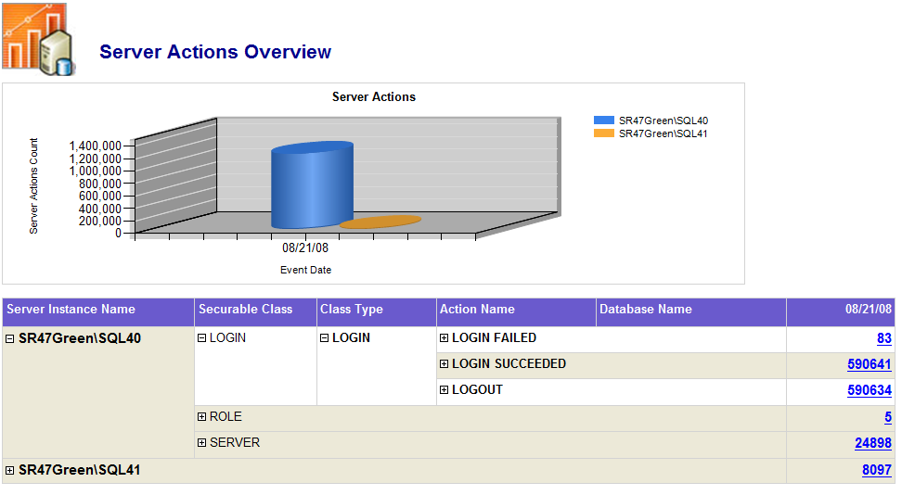

### Server Action Trend Analysis

If you add a range of dates to this, you will notice the large number of login successes, but you will also see that various bulk admins and login failed. Further analysis reveals an interesting pattern concerning failed logins. We viewed the Server Actions Overview report for the three days spanning 8/19/2008 to 8/21/2008 and focused only on the **Login Failed** action, as you will notice in Figure 18.

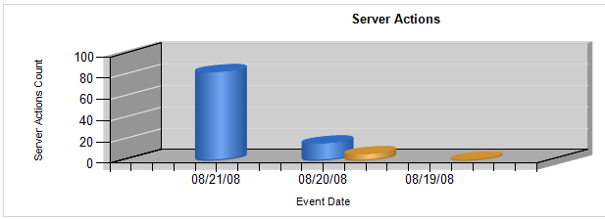

**Figure 18:** Server action trend analysis report

In this particular scenario, there were more login failures on 8/21/2008 than all other days. This is an example of an aggregate report that provides actionable intelligence – in this case, to dig into the details of why there were login failures on these days.

### Drilling Through to the Server Action Details

If we go back to Figure 17, we can also drill through to the details of this report to view more information about this failed logins. In this example, there were 83 failed logins. By clicking on that number, you can view the details of those failed logins.

**Figure 19:** Server actions detail report

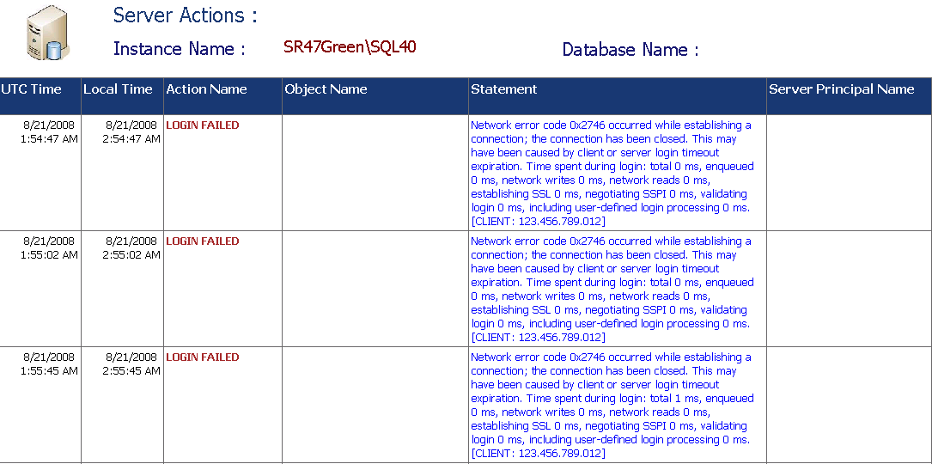

### Overview – Database Actions

Just as you can view a report of server actions, you can view your audit events by the number of database actions performed. As you can see in **Figure 20**, there are two server instances, which had three and four database actions on 8/21/2008.

**Figure 20:** Database actions report

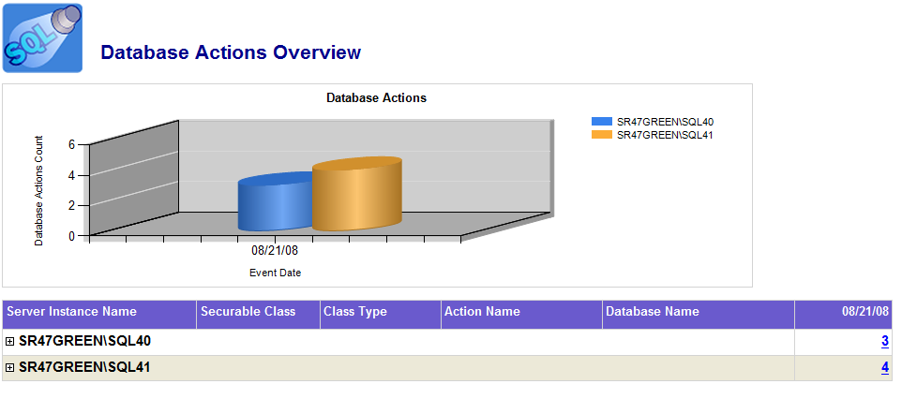

### Drilling Through to the Database Actions

This report shows that there were three GRANT actions against the **DataCollectionSPW** database, while there were four CREATE actions on the **master** database. Drilling through to the details (by clicking on the number) quickly tells you that the four CREATE statements were just RESTORE LABELONLY statements performed by MYDOMAIN\Sql (login).

**Figure 21:** Database actions detail report

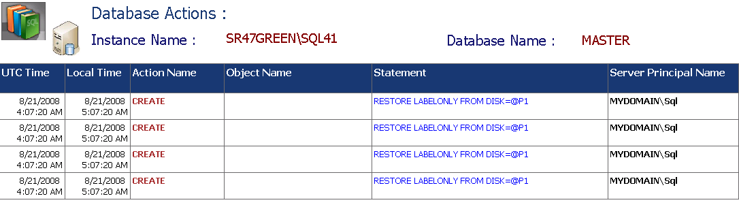

**Note:** When you back up a user database, you need CREATE permissions on the **master** database in order for you to look at the backup media. The CREATE permission is a misnomer, since you are not creating it, but nevertheless this permission is required to do a backup - hence the RESTORE LABELONLY statements in the audit below.

### Overview – DDL Actions

To understand what data definitions have occurred in your environment, you can view the **Overview – DDL Actions** report as shown in **Figure 22**. In this case, on 8/20/2008, there were 44 DROP TABLE statements for the SQLDBADMIN database for the noted server instance.

**Figure 22:** Database DDL report

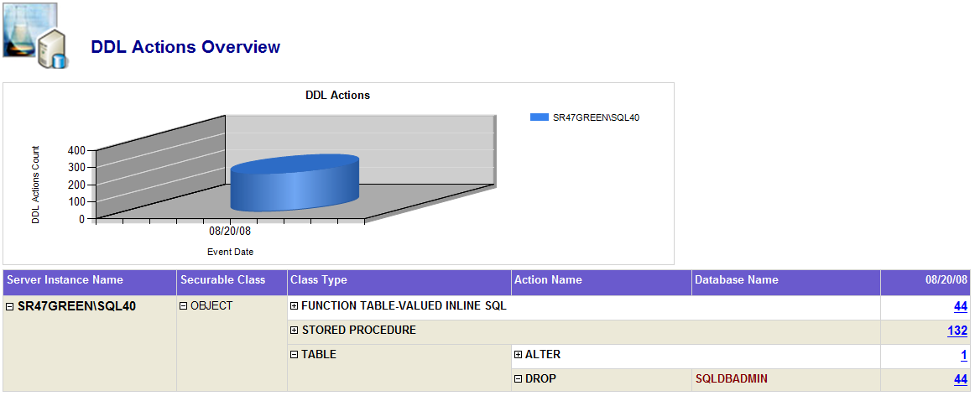

### Drilling Through to the DDL Actions

To ensure that the DROP TABLE statements are valid, you can drill through to the individual DDL actions. They provide the time, action, object name, and statement used for the drop, so you can validate the actions taken.

**Figure 23:** Database DDL detail report

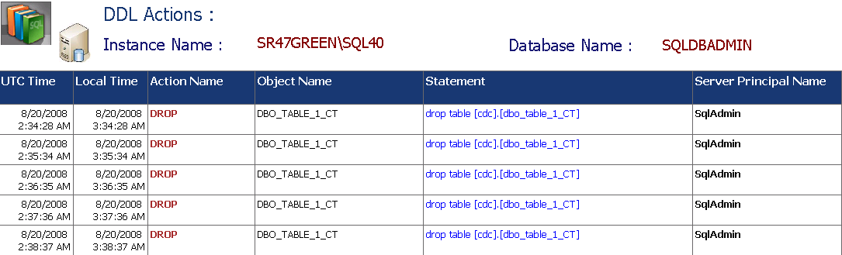

### Overview – DML Actions

You can even review the type of DML statements that have been executed throughout your environment. The **Overview – DML Actions** report tells you that on 8/21/2008, four DELETE statements were executed on your SQLDBADMIN database.

**Figure 24:** Database DML report

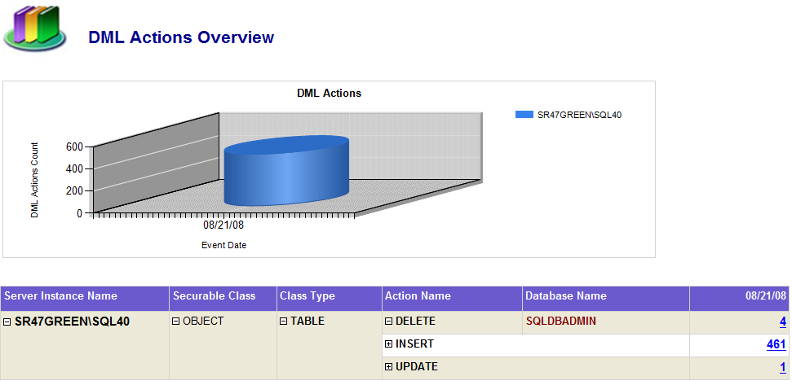

### Drilling Through to the DML Actions

This report provides details that can help you determine the validity of each DML action. By clicking on “4”, you can see the complete DELETE statements as well as the Server Principal Name of the user that performed them.

**Figure 25:** Database DML detail report

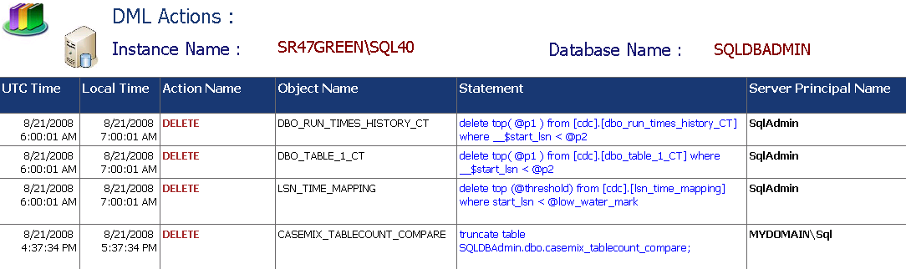

# Using Policy-Based Management to Define, Deploy, and Validate Policy

So far this SDK has shown how to manage security, identity, encryption, and auditing to address compliance needs. This section will provide examples on how to use Policy-Based Management to validate that each of those areas has been properly configured according to policy.

## Policy-Based Management Structure

Policy-Based Management models the computer, the database, and database objects as a hierarchical structure of managed targets with nested target types. Policy-Based Management permits the definition of categories that point to a set of policies. Each policy consists of a single condition that is used to validate the policy. Each condition has one expression which is composed of expression clauses. Each policy can be targeted at a database or database object such as a user, a table, or a stored procedure. See **Figure 26** for a diagram of these concepts. For more information about Policy-Based Management categories, expressions, facets, policies, and targets, see [Administering Servers by Using Policy-Based Management](http://msdn.microsoft.com/en-us/library/bb510667.aspx).

You can define your own set of policies as needed. To get started, you can use the set of policies that come with SQL Server 2008. A description of them can be found [here](http://msdn.microsoft.com/en-us/library/cc645723.aspx).

**Figure 26:** Policy-Based Management objects and their relationships



## Policy-Based Management Example

To map Policy-Based Management to a set of database-related policies, start by creating a category to represent the regulation or policy area your company wants to manage. For example, create a category called PCI if that is a standard you need to follow. Next, create a set of Policy-Based Management policies to match each of the regulatory policies that you want to and are able to automate. Define the conditions needed to validate each of the policies, and target them at the databases that fall under the PCI standard. **Figure 27** shows how Policy-Based Management could be configured for PCI.

**Figure 27:** Policy-Based Management example



## Monitoring Policy-Based Management Policies

Each Policy-Based Management policy can be monitored to ensure it is being complied with. A policy can be monitored on a schedule or when a change occurs in the target for which the policy was created, but not both at the same time. However, both are needed to ensure that a policy was enforced over a specific period and that conditions did not change between scheduled checks. To do this, create two sets of Policy-Based Management policies for each regulatory policy that needs to be represented with Policy-Based Management.

## Using Policy-Based Management to Address Compliance

From the standpoint of compliance, the On Schedule and On Demand capacities of Policy-Based Management allow you to do regular health checks to determine who or what is violating your policies or best practices. The **On change: prevent** option provides you with the ability to prevent users from actually making a change, while the **On change: log** allows the change to occur but logs the action.

### Create a Plan

How you plan to build your policies is strictly a product of the business policies, best practices, and IT standards. Some examples of polices include:

* **Naming conventions:** Use specific naming conventions for your database objects (e.g., your UI stored procedures must have the prefix of usp).
* **No user objects in system databases:** Ensure that no user objects were accidently placed onto your **master**, **msdb**, and **tempDB** databases.
* **Database backup is current:** You can have operational considerations to ensure that your backups are current.(e.g., within the last 24 hours)
* **Standard database properties:** Ensuredatabase properties like auto shrink and auto close are off; or ensure that auto grow is configured properly so the database does not continually grow and cause you to run out of disk space.
* **Validate service accounts:** Ensuredatabase services, such as SQL Server Agent, are using the appropriate service account.
* **Login standards:** In diverse environments, many vendors will create logins (e.g., two-character logins) for their applications. You can build policies that check for this type of creation.
* **sysadmin validation:** Ensurethat the **sysadmin** server role has the appropriate members assigned and that the **sa** account is disabled.

These are a few examples of the types of policies you can create; as you can see, the possibilities are far and wide. But to do this properly, you will first need to develop and understand what your IT standards and best practices are. From there, you will need to categorize and rank the types of policies that you want to deploy.

|  |  |  |  |
| --- | --- | --- | --- |
| Category | Rank | Policy | Execution Mode |
| **Operations** | 1 | Ensure database backup is current | On Schedule |
| 2 | Ensure certificates backup are current | On Schedule |
| … | … | … |
| 28 | Ensure data folder is on H:\ drive | On Demand |
| **Naming Conventions** | 1 | Ensure database name is <50 characters | On Schedule |
| 2 | Ensure database name has no spaces | On Schedule |
| 3 | Ensure database roles are … | On Change : Prevent |
| … | … | … |
| 40 | Ensure stored procedure names do not have “foo” in them | On Demand |

**Table 4:** Policy Ranking by Category

To help plan your policy strategy, develop a table of possible and existing policies. Such a table will tell you what polices have already been created; this information will help you avoid unnecessary policies and policies that conflict or overlap. The table will also help you identify and prioritize new policies.

### Based on the Plan, Which Set of Policies Do You Want to Create?

As noted above, one of the purposes of your policy plan is to identify the priority of your policies. Based on this policy plan, you can create your plan and then deploy new policies incrementally.

The reason for the incremental approach is that you also want to know the impact of your policies on your system. If you start off with a just a few policies, the impact on your system will be negligible. But if over time you develop hundreds of policies that are all scheduled to execute at the same time, then you will find yourself running into resource contention just to understand what violated your best practices or IT standards. Hence the importance of ranking the policies; you know which ones to deploy first.

### Determining Execution Mode for Your Policies

For each of your policies, as per the above plan, you will need to determine the type of enforcement. You may want many of your policies operate “on schedule” to periodically check for policy breaks. But remember that there will be a performance impact on your servers to run these policy validations. Always test policy changes to understand how adding policies can affect performance.

Therefore, differentiate the policies that really require scheduled checking from the ones that can be performed on demand. For example, it does make sense to periodically check that your database backups and certificate key backups are current. But you can probably run the policy check on the location of your SQL Server data folder (e.g., it needs to be on H:\) on an on-demand basis. Meanwhile, it is possible that a user will try to create an invalid database role – in this case, you can create a policy that will prevent the user from even making that change. Or if you want to allow them to make the change, you require that the change is at least logged (i.e., **On change: log**) so you can keep track of the changes being made.

**Table 5** shows the different execution modes, which depend on the policy facet. Execution modes depicted in the table are: Check on Change Prevent (CoC: Prevent), Check on Change Log (CoC: Log) and Check on Schedule (CoS). For more information about which executions are applicable to which facets, see [SQL Server Policy-Based Management: Facets](http://blogs.msdn.com/sqlpbm/archive/2008/05/24/facets.aspx).

|  |  |  |  |
| --- | --- | --- | --- |
| Facet name | CoC: Prevent | CoC: Log | CoS |
| Application Role | X | X | X |
| Asymmetric Key | X | X | X |
| Audit |  |  | X |
| Backup Device |  |  | X |
| Broker Priority |  |  | X |
| Broker Service |  |  | X |
| Certificate |  |  | X |
| Credential |  |  | X |
| Cryptographic Provider |  |  | X |
| Data File |  |  | X |
| Database |  |  | X |
| Database Audit Specification |  |  | X |
| Database DDL Trigger |  |  | X |
| Database Maintenance |  |  | X |
| Database Option |  | X | X |
| Database Performance |  |  | X |
| Database Role | X | X | X |
| Database Security |  |  | X |
| Default |  |  | X |
| Endpoint | X | X | X |
| File Group |  |  | X |
| Full Text Catalog |  |  | X |
| Full Text Index |  |  | X |
| Full Text Stop List |  |  | X |
| Index |  |  | X |
| Linked Server |  |  | X |
| Log File |  |  | X |
| Login |  |  | X |
| Login Options | X | X | X |
| Message Type |  |  | X |
| Multipart Name | X | X | X |
| Name |  |  | X |
| Partition Function |  |  | X |
| Partition Scheme |  |  | X |
| Plan Guide |  |  | X |
| Remote Service Binding |  |  | X |
| Resource Governor |  |  | X |
| Resource Pool | X | X | X |
| Rule |  |  | X |
| Schema | X | X | X |
| Server |  |  | X |
| Server Audit |  |  | X |
| Server Audit Specification |  |  | X |
| Server Configuration |  | X | X |
| Server DDL Trigger |  |  | X |
| Server Information |  |  | X |
| Server Performance |  |  | X |
| Server Security |  |  | X |
| Server Settings |  |  | X |
| Server Setup |  |  | X |
| Service Contract |  |  | X |
| Service Queue |  |  | X |
| Service Route |  |  | X |
| Statistic |  |  | X |
| Stored Procedure | X | X | X |
| Surface Area |  | X | X |
| Surface Area for AS |  |  |  |
| Surface Area for RS |  |  |  |
| Symmetric Key |  |  | X |
| Synonym |  |  | X |
| Table |  |  | X |
| Table Options | X | X | X |
| Trigger |  |  | X |
| User |  |  | X |
| User Defined Aggregate |  |  | X |
| User Defined Data Type |  |  | X |
| User Defined Function | X | X | X |
| User Defined Table Type |  |  | X |
| User Defined Type |  |  | X |
| User Options | X | X | X |
| View |  |  | X |
| View Options | X | X | X |
| Workload Group | X | X | X |
| Xml Schema Collection |  |  | X |

**Table 5:** Facet support execution type

### Using Policy-Based Management to Implement KPIs and KRIs

Key performance indicators (KPIs) and key risk indicators (KRIs) are used by many business people to ensure the proper running of their enterprise. Policy-Based Management can be used to create KPIs and KRIs for the SQL Server database. First create a Policy-Based Management Category to represent the set of KPIs and KRIs that you want to create. Next create a set of policies that can be used to validate that your KPIs and KRIs are within acceptable ranges. For help in creating Policy-Based Management policies, see this [tutorial](http://msdn.microsoft.com/en-us/library/bb522659.aspx).

Policy-Based Management provides [facets](http://blogs.msdn.com/sqlpbm/archive/2008/05/24/facets.aspx) to assist in the creation of KPIs such as Database Performance, Server Performance, Resource Pool, and Plan Guide. After you have created the policies, be sure to monitor them as appropriate or have an alert sent to you if their values fall outside of normal operating ranges.

### Using Policy-Based Management to Validate Auditing Configuration

Policy-Based Management can be used to validate that auditing has been properly configured on your servers. The policies can review the existence of database and server auditing specifications and whether they are enabled.

**Note:** As indicated in the Auditing Sensitive Operations section above, there are different levels of sensitivity, and not all users or objects need to be audited. Therefore, in your policy plan you will need to also take into account that some policies will be applicable to some systems and not others. For example, for the servers that contain private personal information, auditing will need to be turned on to ensure that all actions have been tracked. But for servers that supply general information, you may need only to audit any **sysadmin**-specific actions. In this latter case, you would not want to have a policy ensuring that all actions have been tracked, since it would not provide you with any useful information.

### Using Policy-Based Management to Validate Encryption Configuration

Creating policies to ensure encryption is active is another good way to keep track of the health of your system. Just like auditing, your policies may not be applicable to all available servers. The servers that contain private information require encryption and policies to validate their existence, but for servers that contain general nonprivate information, neither encryption nor the associated policies are necessary. Some policy areas include the following:

* Ensure Transparent Data Encryption (TDE) has been enabled on the databases that require it (e.g., perform this check on databases that contain private information only).
* Ensure the backup of your database is also encrypted.
* Ensure encryption keys have been rotated on a periodic basis (e.g., monthly).
* Ensure that keys have been backed up.
* Ensure that the key backup is in some centralized location.
* Limit access to encryption keys.

### Deploying Policies

There are different methodologies for deploying your policies to multiple servers. One method is to have a central management server that contains all of your policies and export them to a shared location in file format.

**Figure 28:** Exporting a policy

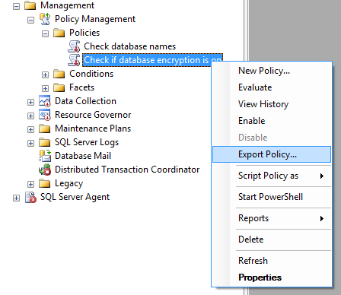

When you want to import your policies, from SQL Server Management Studio you can use the Registered Servers viewer and import these policies for the entire group as shown in **Figure 29**.

**Figure 29:** Importing a policy

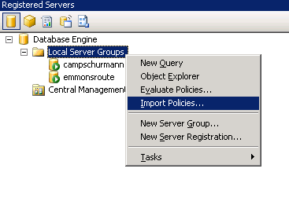

You can also programmatically use Windows PowerShell™ scripts to perform the task of deploying your policies as shown in Deploying Policy-Based Management Policies by Using PowerShell:

### Creating Policy-Based Management Reports

Using the auditing reporting infrastructure, it is also suggested that you have one central location so you can review all of your server policy executions and health states. This way you can audit and monitor the health of your server environment from one central location.

**Figure 30:** Central collection of policy information



As **Figure 30** depicts, you can use your SQLAudit central server as your hub for collecting policy information. Your process (the script below is a PowerShell script) will initially obtain the list of servers that it is supposed to access the policy data. It can then perform the task of extracting data from the necessary tables and placing them onto a file share. This data can then be loaded into your SQLAudit central server so that way you can view the reports.

**Viewing All Policies**

As you can see from the report in **Figure 31**, you can view all of the policies that exist on all of your server instances, including the execution mode, facets, policy, and conditions.

**Figure 31:** Policy-Based Management policy report

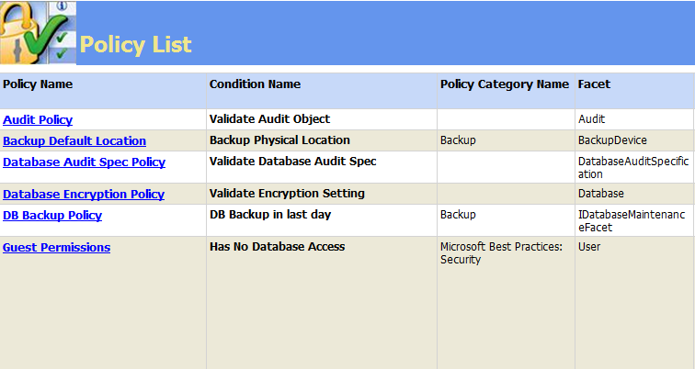

From here, you can drill down to the details – for example, I want to view the “Evaluated Policy” of “Test Policy with Lots of Violations” for the ServerInstanceName “Caregroup” on 6/18/2008.

**Figure 32:** Policy-Based Management detailed policy report

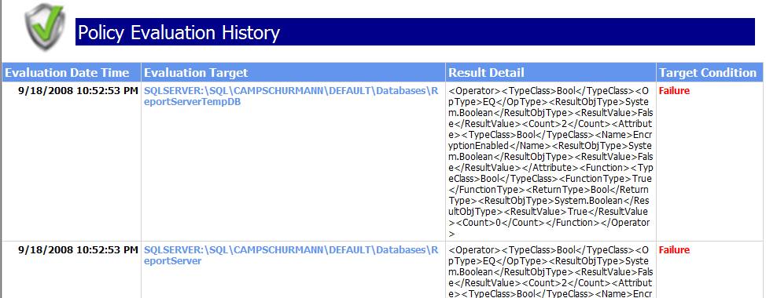

You’ll notice that in **Figure 32**, the policy evaluation report only contains failures. This happens because by default Policy-Based Management records only failure events. To record both successful and failed events, set the Policy Management Properties *LogOnSuccess* parameter to True as noted in **Figure 33**. The *LogOnSuccess* parameter determines whether Policy-Based Management logs successful policy evaluations.

**Figure 33:** Policy Management Properties -

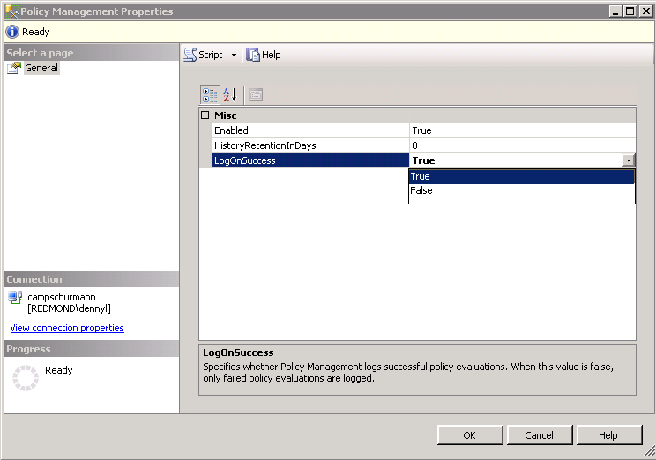

# Helpful Scripts and Tips

This section provides a set of helpful scripts and tips that can be used to assist with the development of compliance solutions as part of commercial applications or organizational applications. Each of these scripts is included in the compliance SDK. Where applicable, the name of the file that contains the scripts is listed as part of the title.

## Programming Interfaces to SQL Server

SQL Server provides several programming interfaces. This section provides an overview of the three that this section uses: SQL Server Management Objects (SMO), Transact-SQL, and Windows PowerShell.

### SMO

[SQL Server Management Objects](http://msdn.microsoft.com/en-us/library/ms162169.aspx) (SMO) is a collection of objects that are designed for programming all aspects of managing Microsoft SQL Server. You can use SMO to build customized SQL Server management applications. The SMO object model extends and supersedes the SQL Distributed Management Objects (SQL-DMO) object model. Compared to SQL-DMO, SMO increases performance, control, and ease of use. Most SQL-DMO functionality is included in SMO, and there are various new classes that support new features in SQL Server.

### Transact-SQL

[Transact-SQL](http://msdn.microsoft.com/en-us/library/ms189826.aspx) is the traditional language to use when interfacing with SQL Server. All applications that communicate with an instance of SQL Server do so by sending Transact-SQL statements to the server, regardless of the user interface of the application. Developers who want to create database applications should familiarize themselves with this language.

### Windows PowerShell

[Windows PowerShell](http://www.microsoft.com/windowsserver2003/technologies/management/powershell/default.mspx) is a command-line shell and scripting language that helps IT professionals achieve greater control and productivity. Using a new admin-focused scripting language, more than 130 standard command-line tools, and consistent syntax and utilities, Windows PowerShell allows IT professionals to more easily control system administration and accelerate automation. Windows PowerShell is now included as part of Windows Server 2008. To get a head start on scripting, check out the [Windows PowerShell Quick Reference](http://www.microsoft.com/downloads/details.aspx?FamilyId=DF8ED469-9007-401C-85E7-46649A32D0E0&displaylang=en).

Several of the examples in this section use PowerShell scripts. Information on using PowerShell with SQL Server can be found [here](http://msdn.microsoft.com/en-us/library/cc281939.aspx). You can also watch a [video](http://www.microsoft.com/emea/spotlight/sessionh.aspx?videoid=984) on SQL Server PowerShell tips and tricks.

**Note:** Running PowerShell scripts for the first time can be tricky. First make sure that you run SQLPS to get into PowerShell and not POWERSHELL. Next read [Running Windows PowerShell Scripts](http://www.microsoft.com/technet/scriptcenter/topics/winpsh/manual/run.mspx) if you need additional help.

## VBScript

Microsoft Visual Basic® Scripting Edition ([VBScript](http://msdn.microsoft.com/en-us/library/t0aew7h6(VS.85).aspx)) brings active scripting to a wide variety of environments, including Web client scripting in Microsoft Internet Explorer® and Web server scripting in Microsoft Internet Information Services (IIS). VBScript permits the creation of applications that are targeted at SQL Server. A script repository with dozens of examples for SQL Server can be found at [Script Repository: SQL Server](http://www.microsoft.com/technet/scriptcenter/scripts/sql/default.mspx).

## Windows Data Access Components

[Windows Data Access Components](http://msdn.microsoft.com/en-us/library/aa968814(VS.85).aspx) is a set of technologies that provide access to information across the enterprise. These technologies include Microsoft ActiveX® Data Objects (ADO), OLE DB, and Microsoft Open Database Connectivity (ODBC). Data-driven client/server applications deployed over the Web or a LAN can use these components to easily integrate information from a SQL Server database.

# Ensuring Security Settings (Server Security Policy.xml)

The section on Using Windows Authentication discusses the importance of using Windows Authentication mode for server authentication. This can be done manually in SQL Server Management Studio by selecting the mode in the **Security** page of **Server Properties** as shown in **Figure 34**. Policy-Based Management can be used to monitor most server settings. An example of how to do this can be found in the file Server Security Policy.xml.

**Figure 34:** Server security properties

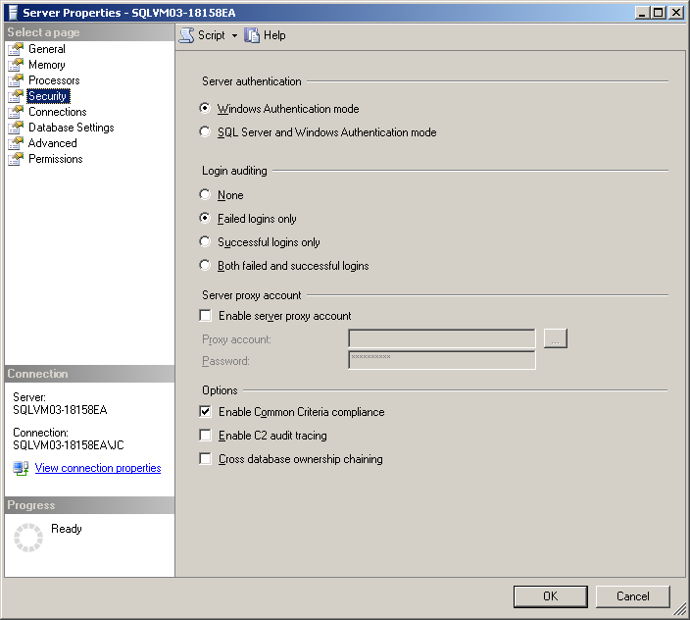

Windows authentication is one example of a security setting that can be used to help restrict access to sensitive data. With Policy-Based Management, database administrators can create policies to ensure that certain security and other settings are appropriately established and maintained. In general, creating a policy for an object’s settings is as simple as right-clicking on the object and then clicking **Facet**. **Figure 35** shows an example or accessing the **Facets** menu after right-clicking the server object:

**Figure 35:** Selecting facets for the server object

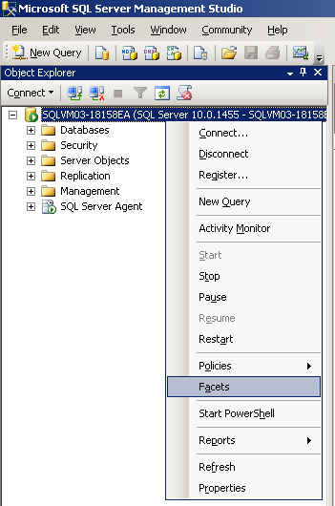

The **View** **Facets** dialog box, shown in **Figure 36**, presents the available facets for the selected object along with the facet’s settings.

**Figure 36:** Policy-Based Management server facet dialog box

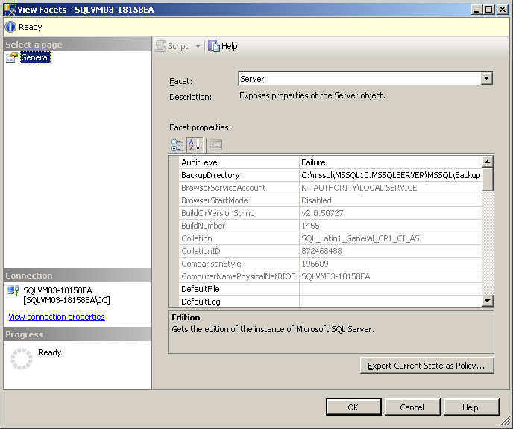

# Managing Separation of Duties (SOD Policy.xml)

The policy file SOD Policy.xml ensures that the **sa** account has been renamed and is disabled. It ensures that only specific users and service accounts have been added to the **sysadmin** role. It ensures that users are only assigned to one role. The remainder of this section shows how to perform these functions manually. This policy contains two scripts that demonstrate the flexibility of Policy-Based Management expressions.

**Note:** When you include scripts as part of a policy condition, a warning icon appears in the **Evaluate Policies** dialog box next to the policy along with the warning statement at the top of the dialog box, as shown in **Figure 37**. The inclusion of scripts also prevents policies from being automatically evaluated from SQL Server Management Studio. However, clicking the **Evaluate** button permits policy evaluation.

**Figure 37:** Policies with scripts highlighted in the **Evaluate Policies** dialog box

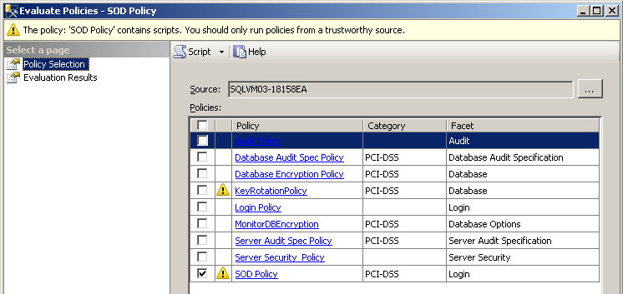

## Using Scripts in Conditions

Using scripts is one of the more powerful ways to configure a condition for Policy-Based Management. Below is one of the ones used by the Validate Roles condition in the SOD Policy policy.

IsNull(ExecuteSql('Numeric',

'SELECT COUNT(DISTINCT name)

FROM sys.server_role_members,

sys.server_principals

WHERE principal_id = member_principal_id

AND role_principal_id

IN (SUSER_ID (''sysadmin''),

SUSER_ID (''bulkadmin''),

SUSER_ID (''securityadmin''))

GROUP BY name

HAVING COUNT(member_principal_id)> 1 '), 0)

The **ExecuteSQL** function permits the embedding of a SELECT statement in a Policy-Based Management expression. This SELECT statement determines whether a user is a member of more than one of the listed security roles. If so, a value greater than zero is returned, causing the condition to fail. The list of roles can be modified as needed. Double apostrophes should be used around role names, because the SELECT statement is embedded in apostrophes. The **IsNull** function is used to force a numeric return in case a NULL result set occurs.

## Disabling All sysadmin Accounts (ManageSA.sql)

Disabling all **sysadmin** accounts provides one sure way to prevent privileged users from accessing data and operations that they shouldn’t. Ordinarily it is not a good idea to disable all **sysadmin** accounts, because only a **sysadmin** can re-enable an account. If that happens, the database could be shut down and placed in [single user mode](http://msdn.microsoft.com/en-us/library/ms188236.aspx) to re-enable a **sysadmin** account. The following code shows how to disable all **sysadmin** accounts.

USE master

GO

CREATE PROCEDURE sp_DisableSA AS

IF (DB_ID() = 1)

BEGIN

DECLARE @cmd nvarchar(max)

-- SID 0x01 is always "sa"

SET @cmd = N'ALTER LOGIN ' + QUOTENAME(SUSER_NAME(0x01)) +

N' DISABLE'

EXEC ( @cmd )

END

ELSE

BEGIN

RAISERROR ('sp_DisableSA is only valid when hosted in master DB', -- Message text.

16, -- Severity.

1 -- State.

);

END

GO

CREATE PROCEDURE sp_EnableSA AS

IF (DB_ID() = 1)

BEGIN

DECLARE @cmd nvarchar(max)

-- SID 0x01 is always "sa"

SET @cmd = N'ALTER LOGIN ' + QUOTENAME(SUSER_NAME(0x01)) +

N' ENABLE'

EXEC ( @cmd )

END

ELSE

BEGIN

RAISERROR ('sp_EnableSA is only valid when hosted in master DB', -- Message text.

16, -- Severity.

1 -- State.

);

END

GO

-- Create the certificate for signing the stored procedure

CREATE CERTIFICATE SACert WITH SUBJECT = 'For signing stored procedures'

GO

-- Permit login to execute stored procedure

GRANT EXECUTE ON sp_DisableSA TO [SQLVM03-18158EA\Pat];

-- Sign the stored procedure

ADD SIGNATURE TO sp_DisableSA BY CERTIFICATE SACert;

-- Create a certificate-based login

CREATE LOGIN [CertLogin] FROM CERTIFICATE SACert;

-- Add the login to the sysadmin role so the stored procedure

-- can disable the sa account

EXEC sp_addsrvrolemember [CertLogin], N'sysadmin';

-- Remove the private key so the stored procedure cannot be re-signed

ALTER CERTIFICATE [SACert] REMOVE PRIVATE KEY;

-- Modify your server audit specification to track the use of the

-- stored procedure as needed. Ensure that the audit specification

-- is disabled before running the ALTER command

ALTER SERVER AUDIT SPECIFICATION [Audit Login Changes]

WITH (STATE = OFF)

GO

ALTER SERVER AUDIT SPECIFICATION [Audit Login Changes]

ADD (SERVER_PRINCIPAL_CHANGE_GROUP)

GO

ALTER SERVER AUDIT SPECIFICATION [Audit Login Changes]

WITH (STATE = ON)

GO

## Validating the sa Account (ValidateSA.sql)

The Validate Roles condition can be used to validate that the **sa** account has been renamed and is disabled. The following script shows how to do it manually.

IF (SELECT COUNT(*)

FROM sys.server_principals

WHERE = principal_id 1

AND is_disabled = 1

AND name != 'sa') = 1

PRINT 'Compliant'

ELSE

PRINT 'Non-compliant'

## Validating sysadmin Role Membership (ValidateSysadmins.sql)

The Validate Roles condition in SOD Policy.xml can be used to validate that only the appropriate users are members of the **sysadmin** role. The following script shows how to do it manually.

DECLARE @Admin1 sysname

DECLARE @Admin2 sysname

DECLARE @Admin3 sysname

DECLARE @Admin4 sysname

SET @Admin1 = @@SERVERNAME + '\Pat'

SET @Admin2 = 'NT AUTHORITY\SYSTEM'

SET @Admin3 = 'NT AUTHORITY\NETWORK SERVICE'

SET @Admin4 = 'sa'

IF EXISTS (SELECT name

FROM sys.server_role_members A,

sys.server_principals B

WHERE A.member_principal_id = B.principal_id

AND role_principal_id = SUSER_ID('sysadmin')

AND name NOT IN (@Admin1, @Admin2,

@Admin3, @Admin4))

PRINT 'Non-compliant'

ELSE

PRINT 'Compliant'

## Enforcing Separation of Roles (SOD Policy.xml)

These scripts validate that a user does not exist in more than one role, and they list the users that exist in more than one role along with the name of the role. One set looks at server roles and the other at server roles.

It is important to note that SQL Server is unable to easily monitor who is a member of Windows security groups. Each organization should create a policy for managing security group membership. If groups are used, it will not be possible for SQL Server to determine whether an individual is a member of multiple SQL Server roles via group memberships.

### Monitoring Server Roles (ValidateServerRoles.sql)

The **Login Properties** dialog box can be used to view a user’s server roles and determine whether the user is in more than one critical role as shown in **Figure 38**.

**Figure 38:** **Login Properties** dialog box

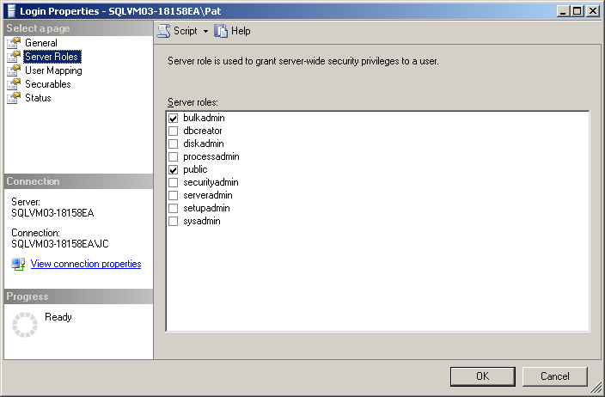

The Policy-Based Management policy file SOD Policy.xml permits monitoring server roles to ensure that a user has not been assigned to more than one role without having to view each user’s roles manually. The script below performs the same function. If a count greater than zero is returned, then a user is a member of more than one of the listed roles.

SELECT COUNT(*)Count

FROM sys.server_role_members, sys.server_principals

WHERE principal_id = member_principal_id

AND role_principal_id

IN (SUSER_ID('sysadmin'), SUSER_ID ('bulkadmin'),

SUSER_ID ('securityadmin'))

GROUP BY member_principal_id

HAVING COUNT(member_principal_id)> 1

### Listing Users in Multiple Roles (ValidateServerRoles.sql)

This script lists the name of users along with the server roles to which they belong whenever the users are in more than one role. In this example, only three server roles are included in the script. The number of roles and role selection can be modified, because it won’t change how the script functions.

SELECT A.Name, B.NAME Role

FROM sys.server_principals A,

sys.server_principals B,

sys.server_role_members C

WHERE A.name IN (SELECT Name

FROM sys.server_role_members,

sys.server_principals

WHERE principal_id = member_principal_id

AND role_principal_id

IN (SUSER_ID('sysadmin'),

SUSER_ID ('bulkadmin'),

SUSER_ID ('securityadmin'))

GROUP BY member_principal_id, name

HAVING COUNT(member_principal_id)> 1

)

AND A.principal_id = C.member_principal_id

AND B.principal_id = C.role_principal_id

ORDER BY Name

### Monitoring Database Roles (ValidateDatabaseRoles.sql)

The **Database User** dialog box can be used to view a user’s database roles and determine whether the user is in more than one critical role as shown in **Figure 39**.

**Figure 39:** User database role membership

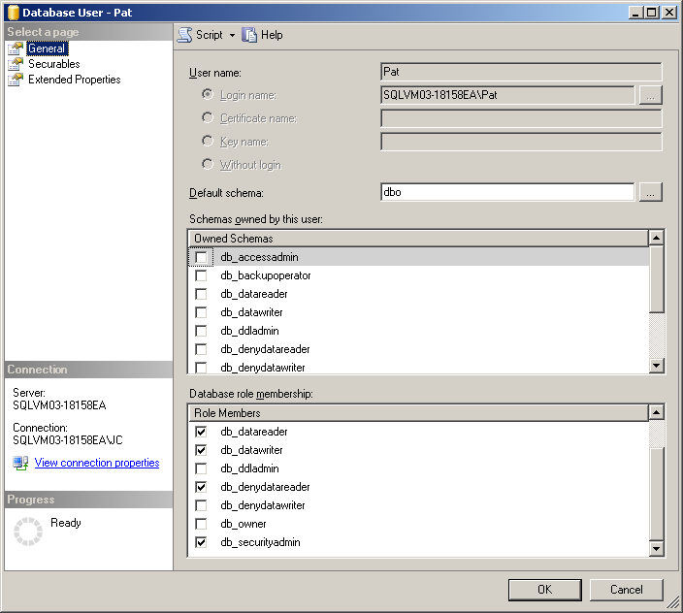

This script lists the users by name along with the number of listed database roles to which the user belongs. The script should return a NULL result set if no user exists in more than one role. In this example, only three database roles are included in the script. The number of roles and role selection can be modified, as it won’t change how the script functions.

SELECT COUNT(member_principal_id) Count, Name

FROM sys.database_role_members,

sys.database_principals

WHERE principal_id = member_principal_id

AND role_principal_id

IN (DATABASE_PRINCIPAL_ID('db_securityadmin'),

DATABASE_PRINCIPAL_ID('db_backupoperator'),

DATABASE_PRINCIPAL_ID('db_datawriter'))

GROUP BY member_principal_id, Name

HAVING COUNT(member_principal_id)> 1

ORDER BY Name

This script lists the name of users along with the database roles to which they belong whenever the users are in more than one of the listed roles. In this example, only three database roles are included in the script. The number of roles and role selection can be modified, as it won’t change how the script functions.

SELECT A.Name, B.Name Role

FROM sys.database_principals A,

sys.database_principals B,

sys.database_role_members C

WHERE A.name IN

(SELECT Name

FROM sys.database_role_members,

sys.database_principals

WHERE principal_id = member_principal_id

AND role_principal_id

IN (DATABASE_PRINCIPAL_ID('db_securityadmin'),

DATABASE_PRINCIPAL_ID('db_backupoperator'),

DATABASE_PRINCIPAL_ID('db_datawriter'))

GROUP BY member_principal_id, name

HAVING COUNT(member_principal_id)> 1

)

AND A.principal_id = C.member_principal_id

AND B.principal_id = C.role_principal_id

ORDER BY Name

# Managing Encryption Keys

Database administrators often use encryption to protect sensitive data and address the proper management of encryption keys as an afterthought. In addition, SQL Server doesn’t provide extensive tools to make it easy to manage encryption keys. This section provides guidance on how to manage keys along with scripts to aid the process.

## Monitoring Access to Encryption Keys (AuditCryptoActions.sql)

SQL Server Audit permits the monitoring of access to encryption keys as well as the encryption setting for databases. Monitoring the events DATABASE_OBJECT_ACCESS_GROUP and DATABASE_OBJECT_CHANGE_GROUP using a server audit specification will help to ensure that any access to the database encryption keys will be logged. Monitoring the event DATABASE_CHANGE_GROUP using a database audit specification will log any changes to the database encryption flag.

Modifying a server audit specification to monitor changes and access to all database objects will not result in many events being logged, because there are few database objects and they are not accessed or changed very often in stable databases. See Monitoring Key Access for a list of objects.

## Viewing Certificates and Keys (ViewKeys.sql)

Certificates for Transparent Data Encryption (TDE) must be created in the **master** database using a script such as the script below. The creation of the master key is only needed if one was not previously created. The master key is needed to protect the certificate.

USE master;

CREATE MASTER KEY ENCRYPTION

BY PASSWORD = 'UseStrongPassword1!';

GO

CREATE CERTIFICATE MyServerCert

WITH SUBJECT = 'My DEK Certificate for Sensitive Data'

After a certificate is created, it can be viewed by running a query against certificates table in the **master** database as shown below.

USE master

SELECT name, certificate_id, start_date, thumbprint, pvt_key_last_backup_date

FROM sys.certificates

**Table 6** shows some important columns from the certificate table. The **start_date** column is what should be used when determining when to re-create the certificate. The **thumbprint** column can be used to determine which databases are associated with the certificate. It maps to the **encryptor_thumbprint** column described later in this section. The **pvt_key_last_backup_date** column indicates when the certificate was last backed up. If the value is NULL the certificate was never backed up. Backup is important because if the certificate is ever destroyed, anything being protected by the certificate, such as backup tapes, cannot be recovered.

|  |  |  |  |
| --- | --- | --- | --- |
| name | start_date | thumbprint | pvt_key_last_backup_date |
| NewServerCert | 2008-07-20 19:43:04.000 | 0xBF372D91C333B1E… | NULL |
| DEKCert_258 | 2008-07-23 04:21:40.000 | 0x99CF8887C56CEC9… | 2008-07-23 04:50:36.553 |
| DEKCert_260 | 2008-07-23 04:51:55.000 | 0x8BFD5885501314B… | 2008-07-23 04:51:56.490 |
| DEKCert_261 | 2008-07-25 05:11:26.000 | 0xC1B737DAFDCFAC… | 2008-07-25 05:11:28.800 |

**Table 6:** Columns from the Certificate Table

Encryption keys for TDE must be created using a script, such as the one below, before TDE can be enabled for a database. A certificate must have previously been created for the encryption key creation to succeed.

CREATE DATABASE ENCRYPTION KEY

WITH ALGORITHM = AES_128

ENCRYPTION BY SERVER CERTIFICATE DEKCert_258

GO

After the key is created, it can be viewed by running a query using the dynamic management view as shown below.

SELECT database_id, create_date, regenerate_date,

encryptor_thumbprint

FROM sys.dm_database_encryption_keys

**Table 7** shows some important columns from the view. The **database_id** column specifies the database for which the key was created. The ID of 2 is for **tempdb**. The **regenerate_date** column indicates the last time the key was regenerated. It will equal the value in the **create_date** column when the key is first created. It is what should be used when determining when to re-create the key. As indicated in the section Rotating Certificates vs. Rotating Keys, it is better to rotate the certificate than the encryption key. The **encryptor_thumbprint** column can be used to determine which certificate is used to protect the key.

|  |  |  |  |
| --- | --- | --- | --- |
| database_id | create_date | regenerate_date | encryptor_thumbprint |
| 2 | 2008-08-20 17:46:28.110 | 2008-08-20 17:46:28.110 | 0 |
| 7 | 2008-07-01 20:27:03.983 | 2008-08-07 16:14:36.013 | 0xC1B737DAFDCFAC9C… |
| 8 | 2008-07-01 20:27:04.137 | 2008-08-07 16:14:36.103 | 0xC1B737DAFDCFAC9C… |
| 9 | 2008-07-01 20:27:32.667 | 2008-08-07 16:14:36.213 | 0xC1B737DAFDCFAC9C… |

**Table 7:** Columns from the sys.dm_database_encryption_keys View

## Rotating Certificates (RotateCerts.sql)

The script below regenerates each certificate in the current database. It should only be run against the **master** database. Only certificates that are a month old and have been used to protect a database encryption key are regenerated. The DATEDIFF function can be modified to change the generation frequency. The ID of the certificate being rotated is used in the name of the new certificate to avoid collisions. After the new certificate is generated, it is used to protect each database encryption key that was protected by the previous certificate. This script can be run as a scheduled job using SQL Server Agent.

**Note:** The private key for each newly created certificate must be backed up as soon as possible in a secure fashion. Failure to do so could result in the inability to restore encrypted data in the event of a loss of the original private key.

DECLARE @Thumbprint varbinary(32)

DECLARE @CertID int

DECLARE @CertName sysname

DECLARE @DB_ID int

DECLARE @cmd nvarchar(max)

-- Use the INSENSITIVE keyword to prevent new certificates

-- created during this script from being processed

DECLARE Certificate_Cursor INSENSITIVE CURSOR FOR

SELECT [thumbprint], [certificate_id]

FROM sys.certificates

WHERE (DATEDIFF(MONTH, [start_date], GETDATE()) > 0 )

AND [thumbprint]

IN (SELECT DISTINCT encryptor_thumbprint

FROM sys.dm_database_encryption_keys)

OPEN Certificate_Cursor;

FETCH NEXT FROM Certificate_Cursor INTO @Thumbprint, @CertID;

WHILE @@FETCH_STATUS = 0

BEGIN

SET @CertName = 'DEKCert' + '_' + LTRIM(STR(@CertID));

SET @cmd = N'CREATE CERTIFICATE ' + QUOTENAME(@CertName) +

N' WITH SUBJECT = ''DEK Certificate'''

EXEC( @cmd )

DECLARE Database_Cursor CURSOR FOR

SELECT [database_id]

FROM sys.dm_database_encryption_keys

WHERE [encryptor_thumbprint] = @Thumbprint

OPEN Database_Cursor;

FETCH NEXT FROM Database_Cursor INTO @DB_ID;

WHILE @@FETCH_STATUS = 0

BEGIN

SET @cmd = N'USE ' + QUOTENAME(DB_NAME(@DB_ID)) + ';' +

N'ALTER DATABASE ENCRYPTION KEY ' +

N'ENCRYPTION BY SERVER CERTIFICATE ' +

QUOTENAME(@CertName)

EXEC (@cmd);

FETCH NEXT FROM Database_Cursor INTO @DB_ID;

END

CLOSE Database_Cursor;

DEALLOCATE Database_Cursor;

FETCH NEXT FROM Certificate_Cursor INTO @Thumbprint, @CertID;

END

CLOSE Certificate_Cursor;

DEALLOCATE Certificate_Cursor;

**Note:** This script will fail if it is run more than two times without the log being [backed up](http://msdn.microsoft.com/en-us/library/ms190440.aspx).

## Backing Up the Certificate Private Key (BackupCerts.sql)

This script looks for each certificate that is used to protect a database encryption key and has not been backed up (**pvt_key_last_backup_date** column is NULL) and backs it up to a file in the C:\certificates directory using the certificate as the file name with the extension “crt”. The private key is backed up to the same directory with the extension “pvt”. After the certificate has been backed up, the private key portion should be immediately stored in a secure location or placed in a database and the file copy should be destroyed.

**Note:** A certificate should not be backed up using a script like this in an automated fashion unless the creation of the password is done securely. Exposing the password in a script makes the private key vulnerable to access. The file should be stored in a safe location or deleted after it is imported into a secondary database. Do not reuse passwords.

DECLARE @CertName sysname

DECLARE @cmd nvarchar(max)

DECLARE Cert_Cursor CURSOR FOR

SELECT [name]

FROM sys.certificates

WHERE [pvt_key_last_backup_date] IS NULL AND [thumbprint] IN

(SELECT DISTINCT [encryptor_thumbprint]

FROM sys.dm_database_encryption_keys)

OPEN Cert_Cursor;

FETCH NEXT FROM Cert_Cursor INTO @CertName;

WHILE @@FETCH_STATUS = 0

BEGIN

SET @cmd =

N'BACKUP CERTIFICATE ' + QUOTENAME(@CertName) +

N' TO FILE = ''c:\certificates\' + @CertName +

N'.crt'' WITH PRIVATE KEY ( FILE = ''c:\certificates\' +

@CertName +

N'.pvk'', ENCRYPTION BY PASSWORD = ''MyPass7779311#'');'

EXEC ( @cmd )

FETCH NEXT FROM Cert_Cursor INTO @CertName;

END

CLOSE Cert_Cursor;

DEALLOCATE Cert_Cursor;

## Ensuring Certificate Rotation and Backup (CertRotationPolicy.xml)

Policy-Based Management can be used to ensure that certificates and keys are rotated according to policy. It can also be used to ensure that certificate private keys are being backed up. The Policy-Based Management policy in the file CetRotationPolicy.xml contains a condition with three scripted expressions that can be used to ensure that certificates and keys are rotated once a month and each certificate private key is backed up.

# Managing Auditing

After audit logs are collected using SQL Server Audit, you may need to process those logs to perform forensics or trend analysis. This section looks at ways to get greater value from logs after they are captured.

## Transferring SQL Server Audit Logs to a Table (StoreAuditLogs.sql)

Logs from multiple systems can collected at a central file share as shown in **Figure 40**. To make it easier to create reports from the logs they need to be moved to a database table. SQL Server Integration Services (SSIS) can be used to create a package that can be run on a schedule. The logs can be moved manually as well using a script. After the logs have been moved to a table, Microsoft Excel® can connect to the table to create charts and do trend analysis. These mechanisms are described in this section.

**Figure 40:** Transferring audit logs to a database table



This script moves events from the SQL Server Audit log file to a database table for easier reporting. This move also prevents a system admin of one of the servers that is sending the events from overwriting the file. There are two things to note:

* SQL Server Audit only stores the codes for the operations and object types in the log file. Therefore, this script performs a join with the action and object tables to include the descriptions, and then it stores them in the database table.
* The name of the last file read along with the offset into the file are loaded into local variables and used when reading the data to prevent the same logs from being loaded twice.

USE [Test1]

GO

DECLARE @data_path nvarchar(256),

@offset int

SET @data_path = NULL

SET @offset = NULL

IF NOT EXISTS (SELECT * FROM sys.objects

WHERE object_id = OBJECT_ID(N'[dbo].[AuditLog]')

AND type in (N'U'))

CREATE TABLE [dbo].[AuditLog](

[event_time] [datetime2](7) NULL,

[sequence_number] [int] NULL,

[action_id] [varchar](4) NULL,

[action_name] [nvarchar](128) NULL,

[succeeded] [bit] NULL,

[permission_bitmask] [bigint] NULL,

[is_column_permission] [bit] NULL,

[session_id] [smallint] NULL,

[server_principal_id] [int] NULL,

[database_principal_id] [int] NULL,

[target_server_principal_id] [int] NULL,

[target_database_principal_id] [int] NULL,

[object_id] [int] NULL,

[class_type] [varchar](2) NULL,

[class_type_desc] [nvarchar](35) NULL,

[session_server_principal_name] [nvarchar](128) NULL,

[server_principal_name] [nvarchar](128) NULL,

[server_principal_sid] [binary](85) NULL,

[database_principal_name] [nvarchar](128) NULL,

[target_server_principal_name] [nvarchar](128) NULL,

[target_server_principal_sid] [binary](85) NULL,

[target_database_principal_name] [nvarchar](128) NULL,

[server_instance_name] [nvarchar](128) NULL,

[database_name] [nvarchar](128) NULL,

[schema_name] [nvarchar](128) NULL,

[object_name] [nvarchar](128) NULL,

[statement] [nvarchar](2000) NULL,

[additional_information] [nvarchar](2000) NULL,

[file_name] [nvarchar](260) NULL,

[audit_file_offset] [bigint] NULL

) ON [PRIMARY]

-- Get the time and offset of the last log entry

SELECT @data_path = file_name, @offset = audit_file_offset

FROM AUDITLOG

WHERE event_time = (select MAX(event_time)FROM AUDITLOG)

INSERT INTO [Test1].[dbo].[AuditLog]

([action_name]

,[class_type_desc]

,[event_time]

,[sequence_number]

,[action_id]

,[succeeded]

,[permission_bitmask]

,[is_column_permission]

,[session_id]

,[server_principal_id]

,[database_principal_id]

,[target_server_principal_id]

,[target_database_principal_id]

,[object_id]

,[class_type]

,[session_server_principal_name]

,[server_principal_name]

,[server_principal_sid]

,[database_principal_name]

,[target_server_principal_name]

,[target_server_principal_sid]

,[target_database_principal_name]

,[server_instance_name]

,[database_name]

,[schema_name]

,[object_name]

,[statement]

,[additional_information]

,[file_name]

,[audit_file_offset])

SELECT name, class_type_desc, C.*

FROM sys.dm_audit_actions A, sys.dm_audit_class_type_map B,

sys.fn_get_audit_file('C:\logs\*', @data_path, @offset) C

WHERE A.action_id = C.action_id

AND B.class_type = C.class_type

## Using SSIS to Move Logs to a Database Table (LoadLogsPackage.dtsx)

As explained in the previous section and shown in **Figure 40**, SQL Server Integration Services (SSIS) can be used to transfer data and perform transformations on the data during the transfer process. **Figure 41** shows the tasks from an SSIS project for moving the data from a SQL Server Audit file to a database table. An initial task creates the audit table if it does not exist. The second task performs the transfer.

**Figure 41:** Two SSIS tasks for collecting audit logs

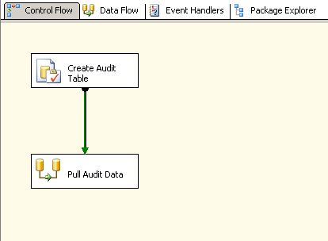

**Figure 42** shows the detail of the transfer task. The raw log data is read from the SQL Server Audit file. It is combined with the action table to retrieve the action name. The data stream is then combined with the class table to get the class type description. The final data is placed into the audit table.

**Figure 42:** Tasks for collecting audit data and storing it in a single table

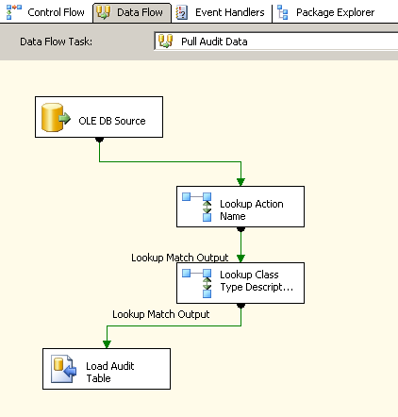

SSIS stores its output in a package that can be loaded in to a job step using SQL Server Agent as shown in **Figure 43**. This permits the automation of the data transfer. Moving data from the log file to a local database mitigates access to the data by administrators. Be sure to discuss this with auditors, as some may be concerned that logs are easier to modify. The file CreateAuditJob.sql creates an audit job that runs every five minutes using the package file LoadLogsPackage.dtsx that is assumed to be located in the directory C:\.

**Figure 43:** SSIS package loaded in SQL Server Agent

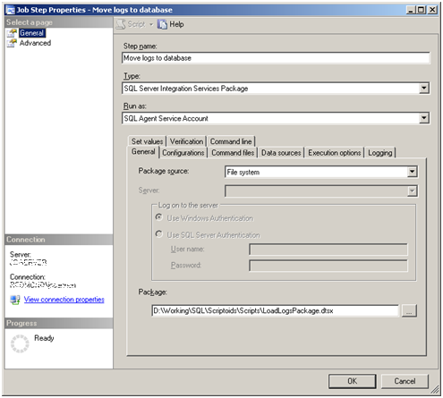

## Accessing SQL Server Audit Events by Using Excel (AuditReport.xlsx)

After data has been stored in a database table, Excel can be used to import the data into a spreadsheet. The same is true for SQL Server Audit logs. Excel provides a familiar mechanism for analyzing data in tabular format. **Figure 44** shows a view of the SQL Server Audit table described in the previous section after it is imported into Excel by using the Data ribbon. Filters can be used to confine the view to a range of dates, actions, objects, and users.

**Figure 44:** SQL Server Audit logs loaded into Excel

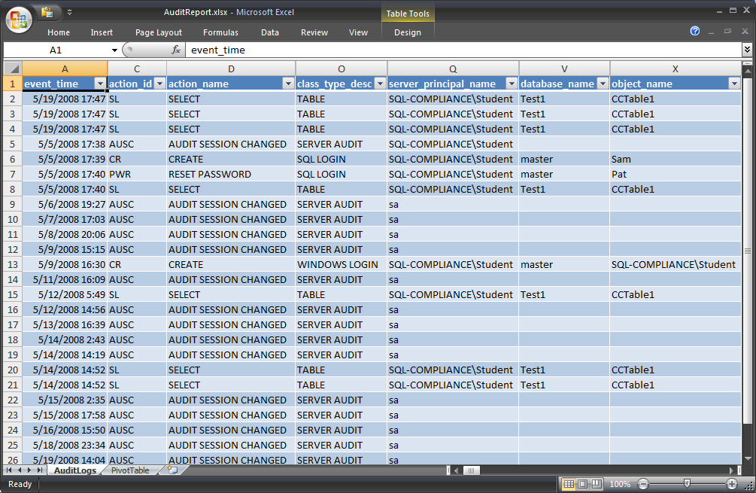

A PivotTable® dynamic view can be created from the data by using the **Insert** ribbon in Excel. **Figure 45** shows an example of a PivotTable that has been created from the audit spreadsheet data. The action, class type, and server principal name fields were included in the PivotTable. A bar graph has been created for the PivotTable that shows the number of actions by type performed against certain objects a user by user ID. The PivotTable field list is used to determine which fields are part of the chart and how they are used.

**Figure 45:** PivotTable generated from SQL Server Audit logs

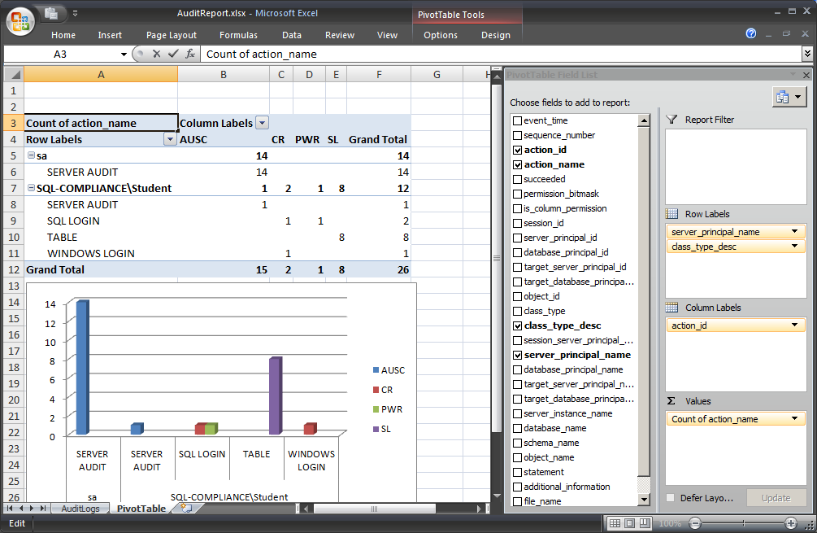

## Getting an IP Address from an Audit Log

When you view audit logs, you can use the server_principal_name field to determine the ID of the user performing the logged operation, where appropriate. However, when a SQL Server account is used connect to the database instead of a Windows account, the server_principal_name field does not provide useful information that makes it easy to determine the individual that performed the operation. However, the logs do provide information that can be used to detect the possible identity of the user. Each log entry contains a session_id. This field maps to the ID assigned to the user when he or she logged in. In the most recent login record (identified by the action id “LGIS”) that has the same ID, the additional_information field will contain the IP address of the computer that connected to the database. Identifying the logs from that computer will determine who was using it at the time that the connection occurred. Below is a script for pulling the IP address from the server_principal_name field.

SELECT event_time, statement,

CAST(additional_information AS XML).value('declare namespace z="http://schemas.microsoft.com/sqlserver/2008/sqlaudit_data";

(//z:address)[1]', 'nvarchar(300)')

FROM sys.fn_get_audit_file('C:\logs\*',Null, Null)

WHERE action_id = 'LGIS'

ORDER BY event_time DESC

## Audit Project

This project was a collaboration between Caregroup Healthcare (Ayad Shammout), Microsoft Consulting Services (Andy Roberts), and SQL Customer Advisory Team (Denny Lee). The goal was to create a working template of an end-to-end audit project that obtains the audit logs, transforms the data, loads the data, aggregates the data, and build your reports. For more information, see the (to be published) *Audit Project Technical Spotlight*.

**Figure 46:** Auditing Project Solution workflow



**Acquire the Solution**

Unzip SQLAudit.zip. It should contain the following files:

* SQLAuditRepositoryDatabase.sql – the SQL file that creates your SQLAudit database
* LoadLogsPackage.dtsx – an SSIS package that performs the task of obtaining, extracting, transforming, and loading the audit data and archiving the audit logs
* SQLAuditReports– A SQL Server Reporting Services (SSRS) solution that you can deploy onto your server so you can view the audit reports

**Create the SQLAudit Database**

This database will be the repository of your audit data.

1. Open the file SQLAuditRepositoryDatabase.sql in SQL Server Management Studio and enable SQLCMD mode (on the **Query** menu, select SQLCMD mode). You will know you’re in SQLCMD mode if your :setvar lines are highlighted in grey.
2. Define the following variables.

|  |  |  |
| --- | --- | --- |
| Variable | Description | Comments |
| DataDirectory | SQL DB data folder (e.g., H:\sqldata\) | Make sure the path ends with a slash “\”. |
| LogDirectory | SQL DB log folder (e.g., H:\sqllog\) | Make sure the path ends with a slash “\”. |
| DatabaseName | Name of your database (e.g., SQLAudit) | None. |

1. Execute the script; your database is created.

**Install the LoadLogsPackageSSIS package**

You will create the configuration files necessary for your SSIS package so that you can execute it.

1. Double click **SQLAuditLoader.SSISDeploymentManifest**. If it doesn't have an associated program, navigate to C:\program files\Microsoft SQL Server\100\DTS\Binn\dtsinstall.exe to open it in the Package Installation Wizard. For more information about installing packages, see <http://msdn.microsoft.com/en-us/library/ms365321(SQL.100).aspx>
2. Click **Next**, click **File system Deployment**, and then click **Next**. Choose an installation folder such as C:\Program Files\Microsoft SQL Server\100\DTS\Packages\SQLAuditLoader, click **Next**, and then click **Next**.
3. Configure the following package properties.

|  |  |
| --- | --- |
| Parameter | Example value |
| **SSIS log provider for SQL Server** | SqlAuditLogRepository |
| **SqlAuditLogRepository**  Provide the name of your SQLAudit database (e.g., SQLAudit) | Data Source=.;Initial Catalog=**$DBName$**;Provider=SQLNCLI10.1;Integrated Security=SSPI;Auto Translate=False;Application Name=SSIS-Package-{21C9032A-E45A-41F2-BA67-9EF35FCD18C3}SqlAuditLogRepository; |
| **User:auditLogArchivePath**  Location to archive the audit logs after processing | D:\audit\logs\archive |
| **User:LogFilePath**  Location of your audit logs | D:\Audit\logs |

These values will be stored in the **LoadLogsPackageConfig.dtsConfig** file. You can alter them manually if you need to make changes after you install the SSIS package.

**Note:** This version of the Audit project assumes a local file directory to obtain the audit logs.

1. Click **Next**, and then click **Finish**.

**Execute the SSIS Package**

When the package is executed, it assumes that there are log files in the D:\audit\logs location (as noted above) and after the log files have been processed, they will be moved to the D:\audit\logs\archive folder.

1. From a command prompt, change to your SQLAuditLoader directory (e.g., C:\Program Files\Microsoft SQL Server\100\DTS\Packages\SQLAuditLoader)
2. Execute the command:

dtexec /ConfigFile LoadLogsPackageConfig.dtsConfig /File LoadLogsPackage.dtsx

**Note:** Make sure you are executing SQL Server 2008 version of DTExec. On servers with multiple instances of SQL Server 2005 and SQL Server 2008, if you run DTExec, DTExect may default to the SQL Server 2005 version (9.00.xxxx) instead of the SQL Server 2008 version (10.00.xxxx). To avoid this, you can fully qualify the path of DTExec (e.g., C:\Program Files\Microsoft SQL Server\100\DTS\Binn\dtexec.exe).

Because there are a lot of audit log files, it is suggested that you run this SSIS package periodically (e.g., every 15 minutes) to ensure that the data is loaded in a timely manner.

**Generate Your Aggregate Reports**

Executing the SSIS package will take the audit logs and populate the aud.AuditLog_[EventType] tables within your SQLAudit database. However, because there are a lot of audit events, it is beneficial to create aggregate reports (i.e., summary reports) that provide a summary view of all of your audits.

* To do this, in SQL Server Management Studio, connect to your SQLAudit database, and then execute the following commands.

exec aud.rspAggServerActions @EventDate = '08/22/2008'

exec aud.rspAggDatabaseActions @EventDate = '08/22/2008'

exec aud.rspAggDMLActions @EventDate = '08/22/2008'

exec aud.rspAggDDLActions @EventDate = '08/22/2008'

These will populate the aud.rptAgg[AuditEvent]Actions tables with your summary statistics.

* It is suggested that you execute these stored procedures (e.g., by using SQL Server Agent) on a nightly basis to keep this daily information up to date. An example of a nightly job script would be:

-- Declare @LastDay variable to set it to last day date

-- the job will run after midnight to aggregate last day data

Declare @LastDay char(11)

select @LastDay = Convert(char(11), getdate()-1 , 1)

Select @LastDay

Exec aud.rspAggServerActions @LastDay

Exec aud.rspAggDatabaseActions @LastDay

Exec aud.rspAggDDLActions @LastDay

Exec aud.rspAggDMLActions @LastDay

**Which Partition Has Your Data?**

The SQL script to create your audit database (SQLAudit) will automatically create twelve monthly filegroups starting from the month you executed the script. As well, the partition scheme and functions will ensure that the aud.AuditLog_% tables are partitioned by month and correlated to the monthly filegroups. To view which rows of data are in which table partitions, use the following script.

select partition_id, OBJECT_NAME(object_id), object_id, index_id, partition_number, partition_id, rows as [RowCount], x.value

from sys.partitions

left outer join (

select boundary_id, value

from sys.partition_range_values

where function_id = (

select function_id

from sys.partition_functions

where [name] = 'monthly_partition_function'

)

) x

on x.boundary_id = partition_number - 1

where OBJECT_NAME(object_id) like 'AuditLog%' and index_id = 1

order by OBJECT_NAME(object_id), partition_number

**View Your Reports**

As noted in the Auditing Sensitive Operations section above, there are a number of reports that can be generated by the audit logs. You can view these reports by deploying the SQLAuditReports Reporting Services solution.

1. Open the SQLAuditReports Reporting Services solution within the Microsoft Visual Studio® development system.
2. Change the Deployment TargetServerURL to your server, i.e., change <http://campschurmann/> to your server name.

**Figure 47:** SQL AuditingReports Property Page

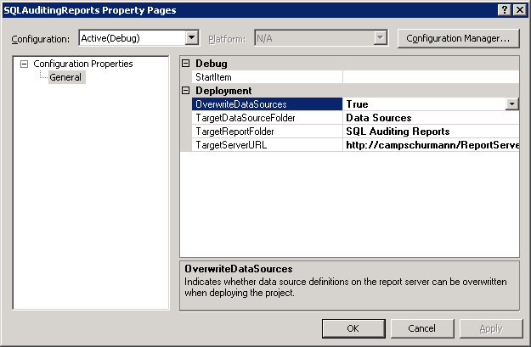

1. Ensure your SQLAudit.rds shared data source is pointing to your own SQLAudit database (vs. some other server’s version of the SQLAudit database).
2. Deploy your reports (Build > Deploy) and you can view your reports at: http://[Your Server Name] /Reports/Pages/Folder.aspx?ItemPath=%2fSQL+Auditing+Reports&ViewMode=List

**Known Issues**

* There are times where the audit logs do not record the server instance name; i.e., the server instance name field is empty within the audit logs. To work around this, the SSIS package will go through the entire audit log and determine the server instance name and assign that name to the entire log (because an audit log comes from only one server). But there are situations where even that will not work, because the entire file has no server instance name. To mitigate this, set up your audit logs with the naming convention

SQLAudit$*%Server$InstanceName%*_%GUID%.sqlaudit

[aud].[fn_GetServerInstanceName] will parse the name of the audit file, pull out the highlighted %Server$InstanceName%, and use this name if one does not already exist. To name your log file with this naming convention, when you create your server audit, alter the name of your audit with the format of SQLAudit$Server$InstanceName.

# Managing Policy-Based Management Policies

Policy-Based Management is a great way to automate the management of databases. Multiserver management and script-based management using Policy-Based Management is not straightforward. This section provides guidance and scripts for enhancing the capabilities of Policy-Based Management.

## Creating a Policy by Using PowerShell

A great resource to learn how to create a policy using PowerShell (instead of manually through SQL Server Management Studio) can be found in Sethu’s blog linked below.

<http://blogs.msdn.com/sethus/archive/2008/06/16/sql-2008-powershell-script-for-creating-a-policy-and-saving-to-file.aspx>

The Microsoft.SqlServer.Management.Dmf namespace contains classes that represent the SQL Server Policy-Based Management objects.

For more information, see <http://msdn.microsoft.com/en-us/library/microsoft.sqlserver.management.dmf.aspx>.

## Deploying Policy-Based Management Policies by Using PowerShell (DeployPBMPolicies.ps1)

The following PowerShell script can be used to deploy Policy-Based Management scripts to another database instance:

# Export Policies from a Server

$policydir = "C:\Policies\"

del C:\Policies\*

$sourceserver = "<Machine>\<Instance>"

$conn = new-object Microsoft.SQlServer.Management.Sdk.Sfc.SqlStoreConnection("server=$sourceserver;Trusted_Connection=true");

$polstore = new-object Microsoft.SqlServer.Management.DMF.PolicyStore($conn);

$fileprefix = "ExportedPolicy_"

$policycount = 0

#Temporary workaround until we fix a bug.

#$sourcepolicycount = $polstore.Policies.Count;

foreach ($policy in $polstore.Policies)

{

$policycount++;

$StringWriter = New-Object System.IO.StringWriter;

$XmlWriter = New-Object System.XMl.XmlTextWriter $StringWriter;

#$polstore.ExportPolicy($polstore.Policies[$policy.Key], $XmlWriter);

$policy.serialize($XmlWriter);

$XmlWriter.Flush();

$StringWriter.Flush();

$outputfile = $policydir + ("{0}.xml" -f (Encode-SqlName $policy.Name));

$StringWriter.ToString() | out-file $outputfile;

}

if ($policycount -gt 0)

{

Write-Host $policycount "of" $sourcepolicycount "policies have been exported to" $policydir -foregroundcolor "green"

}

else

{

write-host "No policies were exported" -foregroundcolor "red"

}

# Import policies to multiple servers

$policylocation = "C:\Policies"

$serversfile = "C:\Servers.txt"

$servercount = 0

$servers = Get-Content $serversfile

foreach ($server in $servers) {

$servercount++;

$conn = new-object Microsoft.SQlServer.Management.Sdk.Sfc.SqlStoreConnection("server='$server';Trusted_Connection=true");

$polstore = new-object Microsoft.SqlServer.Management.DMF.PolicyStore($conn);

foreach ($fileobject in get-childitem $policylocation){

$file = $fileobject.FullName

$reader = [System.Xml.XmlReader]::Create((convert-path $file));

$output = $polstore.ImportPolicy($reader, 0, $true, $true);

}

}

if ($servercount -gt 0)

{

Write-Host "Policies have been imported to" $servercount "servers." -foregroundcolor "green"

}

else

{

write-host "No policies were imported" -foregroundcolor "red"

}

## Transferring Policy Health Checks into a Database Table

Below is a set of PowerShell and SQL scripts that extracts and loads policy information from multiple servers and places this information in a central location for you to view.

**Note:** The policy health check transfer below does a direct database table transfer of the policy data from the **msdb** database to your central database. A potentially better way of doing this is Dan Jones’ PBMTalk, which is included in this SDK as well. For more information, see the PMTalk folder, which contains a PowerPoint presentation, Policy-based Class diagram, and Policy-Based Management code to export the Policy-Based Management data.

**Acquire Solution**

Unzip Policy.zip to your folder of choice (e.g., D:\audit\code\Policy)

**Update the SQLAudit Database**

Use this database as your central server. To add the necessary policy data, install PolicyLoad.sql on the central server where you want to review all of your reports, e.g., the server that contains your SQLAudit audit database. This way, your central SQLAudit database now has both all policy and audit data.

On your central SQLAudit database, populate the **pol.ServerList** table with all of the servers you want to extract policy information from. For example:

insert into pol.ServerList values ('campschurmann', 1)

insert into pol.ServerList values ('emmonsroute', 1)

insert into pol.ServerList values ('emmonsglacier', 0)

where 1 is enabled and 0 is disabled.

**Execute Your PowerShell Script**

As noted in Using Policy-Based Management to Define, Deploy, and Validate Policies, the purpose of this script is to read the above noted **pol.ServerList** table and loop through all of the servers listed in this table, extract the policy data, and then load the data into a central server. Copy the PowerShell script PolicyExLoad.ps1 to your central server, e.g., D:\audit\code\Policy

Ensure that this folder also has an archive folder (e.g., D:\audit\code\Policy\archive)

This is a PowerShell script that needs the SQL Server snap-ins, so ensure that you’ve run ‘sqlps’ before you open your regular command prompt (vs. a PowerShell command window).

From the command line, you can execute the following.

.\PolicyExLoad.ps1 "[SQLCentral]" "[Database]" ”[Date]” “[Folder]”

**SQLCentral:** The server instance that contains your central database (i.e., your SQLAudit database)

**Database:** In most cases, the SQLAudit database.

**Date:** The last date (i.e., one day) on which your polices were executed. If you want all of the policy information, use quotation marks “” to obtain all data.

**Folder:** Your central repository of policy log files; recall that you will want an archive folder in this location as well.

From here, the script will connect to each server, extract the policy data, and then write this as a CSV file onto a log share. Note that there are two types of policy data:

* **Policy dimension tables:** These tables contain the basic constructs of the policies (policy name, conditions, categories, etc.). If a policy is modified or deleted, this information will be updated within the respective **msdb** tables in the remote servers policy data. In the case of our script below, it will obtain the policy name, condition, and category information in the following tables:
  + **syspolicy_policies**
  + **syspolicy_conditions**
  + **syspolicy_policy_categories**
* **Policy fact tables:** Because these tables contain the execution history and health state details, the data within these tables is not updated (only new events are inserted). Our script below obtains the execution history, execution history details, and health state in the following tables:
  + **syspolicy_policy_execution_history**
  + **syspolicy_policy_execution_history_details**
  + **syspolicy_system_health_state**

The extraction script will then create CSV files for each table with the following name convention:

ServerName_[policytable]_yyyyMMdd_hhmmss.csv

The PowerShell script will then access the **[pol].[uspImportPolicyData]** stored procedure, which has some additional business logic to import each *.csv file into the appropriate table.

* If the file is for a policy dimension table, the data will first be placed into a staging table. Then all data associated with the server instances within the staging table will be removed from the policy table. The reason for this is that you want to have the latest policy information (e.g., created by whom, what facets and conditions are being used, updated text, etc.). Then the staging table will be used to populate the policy table.
* If the file is for a policy fact table, the file is simply uploaded directly into the appropriate fact table. We are not concerned about duplicates, because the policy fact tables have unique indexes that ensure no duplicates get into the system. Even if you have multiple policy fact files that were executed multiple times, you can still execute them. The database will ensure that any duplicate data will not be included.
* After the file has been imported, it will be moved to the **Folder\archive** directory so it isn’t processed again.

**View Some Policy Reports**

Install the SQL script PolicyReports.sql on your central server and database (where you installed the PolicyLoad.sql).

As noted in Using Policy-Based Management to Define, Deploy, and Validate Policies, there are a number of reports that can be generated by the audit logs. You can view these reports by deploying the [Policy Reports - PBM] Reporting Services solution.

* Open the [Policy Reports PBM] reporting services solution within Visual Studio
* Change the Deployment TargetServerURL to your server, i.e., change <http://campschurmann/> to your server name.

**Figure 48:** [Policy Reports – PBM] RS Solution Property Page



* Ensure your SQLAudit.rds shared data source is pointing to your own SQLAudit database (vs. some other server’s version of the SQLAudit database).
* Deploy your reports (Build > Deploy). You can view your reports at: http://[Your Server Name] /Reports/Pages/Folder.aspx?ItemPath=%2fSQL+Auditing+Reports&ViewMode=List

# Conclusion

Microsoft and the SQL Server team are committed to providing technology that will help customers and partners address their compliance concerns. SQL Server 2008 provides the technology and capabilities that organizations count on to manage the growing challenges of managing data and delivering actionable insights to users. With significant advancements in key areas, SQL Server 2008 provides a platform for the agile development of compliance solutions.

This white paper provides only an overview of the compliance-related features and functionality in SQL Server 2008. We plan to increase our compliance-related capabilities in future releases. Look for additional compliance-related content at <http://www.microsoft.com/sql>.

**For more information:**

<http://www.microsoft.com/sqlserver/>: SQL Server Web site

<http://technet.microsoft.com/en-us/sqlserver/>: SQL Server TechCenter

<http://msdn.microsoft.com/en-us/sqlserver/>: SQL Server DevCenter

<http://www.microsoft.com/sqlserver/2008/en/us/wp-sql-2008-security.aspx>: SQL Server Security White Paper

<http://forums.microsoft.com/MSDN/ShowForum.aspx?ForumID=1626&SiteID=1>: SQL Server Security Forum

<http://blogs.msdn.com/sqlsecurity/>: SQL Server Security Blog

<http://blogs.msdn.com/sqlpbm/>: SQL Server Policy-Based Management Blog

Did this paper help you? Please give us your feedback. Tell us on a scale of 1 (poor) to 5 (excellent), how would you rate this paper and why have you given it this rating? For example:

* Are you rating it high due to having good examples, excellent screen shots, clear writing, or another reason?
* Are you rating it low due to poor examples, fuzzy screen shots, or unclear writing?

This feedback will help us improve the quality of white papers we release.

[Send feedback](mailto:sqlfback@microsoft.com?subject=White%20Paper%20Feedback:%20SQL%20Server%202008%20Compliance%20Guidance).

# 